VULNERABLE ADULTS AND CUCKOOING
For professionals
Objectives
- To increase knowledge around the exploitation of vulnerable adults.
- Raise awareness of the signs and processes groomers might use.
- To provide real life scenarios that aid participants in identifying risks and safety strategies.
- Increase confidence in supporting vulnerable adults and young people at risk of/or being exploited.
- Reflect on practice and opportunities to engage with vulnerable adults and young people when faced with barriers, such as control (i.e. that from perpetrators).

Films & Resources
- Film: Joe – Drug/Gang Exploitation
- Film: Joe – Gangs/Drugs in Traphouse
- Angie’s Character Life Journey

- ANGIE IN THE CAR (FILM IS REFERRED TO AS JOE – DRUGE/GANG EXPLOITATION)
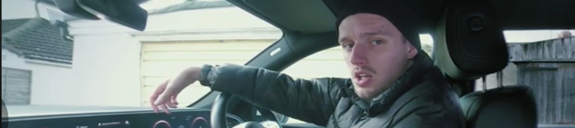
Prompts for facilitating discussion
- What happened in this video?
- Is this exploitation? If so, why?
- How might Angie be feeling?
- What risks do you think Angie may face?
- What do you think might happen if Angie gets caught by the police?
- What might happen if Angie loses the drugs/gets them taken away?
- What would your advice to Angie be in this situation?
- Who could Angie speak to about this?
- Do you think Pete is displaying controlling behaviour? If yes, explain how.

- ANGIE AND JOE IN THE TRAP HOUSE (FILM IS REFERRED TO AS JOE - GANGS/DRUGS IN TRAPHOUSE)
Prompts for facilitating discussion
- What is a “trap house”?
- What is “cuckooing”?
- Name five things that you’ve noticed.
- What do you think Zac means by “the pharmacy is here for you now”?
- Is Angie at risk?
- What have you observed that makes Angie vulnerable?
- How might you support them?
- Is this exploitation? If so, who is being exploited in this video?

- ANGIE’S PROFILE
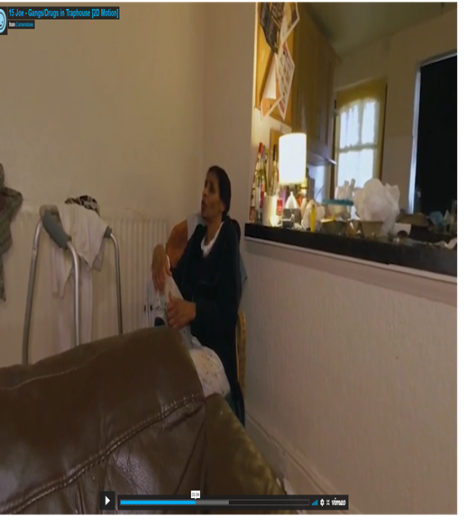

Prompts for facilitating discussion
- Action: Read Angie’s life journey document.
  - Does this change your views now you have more detail?
  - Do you think Angie has capacity to make informed decisions?
  - How might you support Angie?
  - Who would you contact?
  - Discussion point around professional duties: If you’re the social worker/carer/housing officer for Angie, what are your duties towards Joe and/or Angie?

