IDENTITY AND CRIMINAL EXPLOITATION
For professionals
Objectives
- To improve knowledge around trauma-informed responses.
- To increase knowledge around exploitation and increase parent/carer/professional awareness of the signs and process groomers might use.
- To provide real-life scenarios that aid children and young people in identifying risks and safety strategies.
- To provide real-life scenarios to aid parents/carers/professionals in increasing self-awareness.
- To raise awareness around the importance of self-care, prompting participants to value it in their lives.
- To increase confidence amongst participants supporting vulnerable children and young people.

Films
- Joe Introduction
- Joe A at Home
- Joe B at Home
- Joe with Friends
- Joe – Drug/Gang Exploitation
- Joe – Gangs/Drugs in Traphouse

- JOE INTRODUCTION
In this film, we see various things that may make Joe frustrated, vulnerable or isolated.
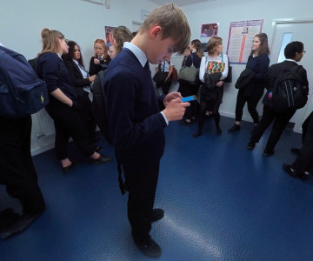
Prompts for facilitating discussions
- How did you find watching that film? How are you feeling now?
- What were some factors you noticed impacting Joe? (E.g. peer relationships, relationship with his birth family, response of the teacher, importance of phones for young people).
- What do you think is the priority for Joe?
- What might have made a difference for him in this situation?
- What do you notice about the way he is managing the situation?
- How could the teacher have managed it differently?

- JOE AT HOME A

Prompts for facilitating discussion
- Describe what you saw in this film.
- What did you think about the carer’s response?
- What did you think about Joe’s response?
- How do you think Joe is feeling?
- How do you think the carer is feeling?
- How would you support this situation?

- JOE B AT HOME
Prompts for facilitating discussion
- What do we notice in this video?
- How is the carer’s response different? (Think stepping back, taking breaths and trying to reconnect with Joe).
- If you feel triggered, do you know what you can do to make yourself feel better, to self-regulate?
- Task: Complete the Self-Care Wheel.
- Did this feel easy to complete? Are the activities you’ve written down something that you can do easily?
- Can you describe how you might respond if in this situation?

- JOE WITH FRIENDS
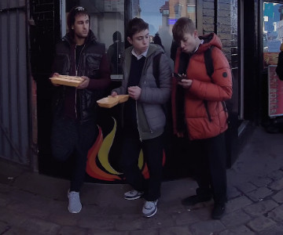
Prompts for facilitating discussions with professionals
- What is important for the young person in this interaction? (Identity and belonging, peer pressure, keeping up with others, access to money and independence, lack of options to get a new phone, feeling alone throughout the situation, risk taking).
- What did you notice in this film? What stood out for you?
- If you were Joe’s key worker (e.g. social worker, youth worker or teacher) and saw him at the chicken shop, as the youth worker did in this film, how would you support Joe?

- JOE – DRUG/GANG EXPLOITATION

Prompts for facilitating discussion with professionals
- How do you think Joe is feeling?
- Who does Joe have that he could talk to about this?
- What is Joe getting out of this? Why do you think he wants to be involved?
- What might stop him from stepping further in?
- What ideas do you have to create connections for Joe?
- What do we know about Joe’s brain and his ability to make decisions in this situation? To understand the impact and consequences of these interactions and activities?

- JOE – GANGS/DRUGS IN TRAPHOUSE
Health warning! The film you are about to watch contains scenes viewers may find difficult.
Prompts for facilitating discussion with professionals
- How did you find watching that clip?
- How are you feeling now?
- How do you think Joe is feeling?
- What fears does Joe have? What fears do you have?
- Who does Joe have that he could talk to about this?
- What is Joe getting out of this? Why do you think he wants to be involved?
- Do you think Joe knew it was going to be like this?
- If you knew Joe was here, what would you do?
- If Joe shared with you what was going on, how would you manage it?
- How is Joe going to get out of this?
- What other connections could help Joe not be in this situation or to get out of it?

Consider…
- Young person’s early experiences
- Imagine they were the child in Carnaby Street
- Relationship with Dad
- Relationship with Foster Mum
- The impact of early trauma on senses of self-worth and self-esteem
- Lack of trust in adults
- Developmental stage and milestones, developmental needs and priorities of teenagers
- Developing identity
- Priorities, decision making capacity, risk taking and understanding consequences

Resources/further reading
- https://assets.publishing.service.gov.uk/media/65322ad1e839fd001486720d/2023_FOR_PUBLICATION_-_Criminal_exploitation_of_children_young_people_and_vulnerable_adults_county_lines1.pdf
- https://www.youngminds.org.uk/young-person/coping-with-life/trauma/

