IDENTITY AND CRIMINAL EXPLOITATION
For parents & carers
Objectives
- To improve knowledge around trauma-informed responses.
- To increase knowledge around exploitation and increase parent/carer/professional awareness of the signs and process groomers might use.
- To provide real-life scenarios that aid children and young people in identifying risks and safety strategies.
- To provide real-life scenarios to aid parents/carers/professionals in increasing self-awareness.
- To raise awareness around the importance of self-care, prompting participants to value it in their lives.
- To increase confidence amongst participants supporting vulnerable children and young people.

Films
- Joe Introduction
- Joe A at Home
- Joe B at Home
- Joe with Friends
- Joe – Drug/Gang Exploitation
- Joe – Gangs/Drugs in Traphouse

- JOE INTRODUCTION
In this film, we see various things that may make Joe frustrated, vulnerable or isolated.
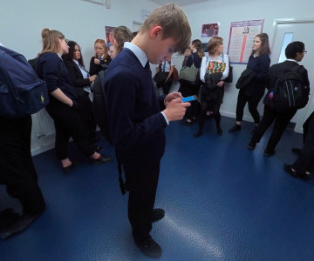
Prompts for facilitating discussion with parents/carers
- How did you find watching that film?
- How are you feeling now?
- What were some factors you noticed impacting Joe? (E.g. peer relationships, relationship with his birth family, response of the teacher, importance of phones for young people).
- What do you think is the priority for Joe?
- What might have made a difference for him in this situation?
- What do you notice about the way he is managing the situation?
- How could the teacher have managed it differently?

- JOE AT HOME A
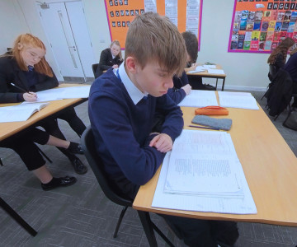
Prompts for facilitating discussion with parents/carers
- What do you think about the way the carer responded to Joe at the start?
- How might his carer be feeling when Joe shouts and swears? (Prompt! Might this be a focus on the behaviour if it challenges your own values)
- What did you notice about carer’s body language/tone of voice?
- How might she be feeling, physically and emotionally?
- Do you think his carer was triggered (and does everyone know what triggered means)?
- How would you notice if you become triggered?
- What do you think Joe’s carer could have done differently?

- JOE B AT HOME
Prompts for facilitating discussion
- What do we notice in this video?
- How is the carer’s response different? (Think stepping back, taking breaths and trying to reconnect with Joe).
- If you feel triggered, do you know what you can do to make yourself feel better, to self-regulate?
- Task: Complete the Self-Care Wheel.
- Did this feel easy to complete? Are the activities you’ve written down something that you can do easily?
- Can you describe how you might respond if in this situation?

- JOE WITH FRIENDS
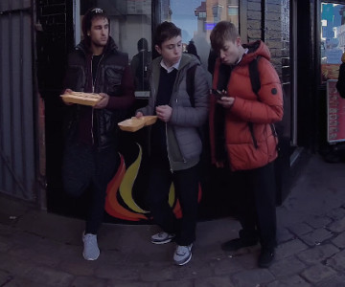
Prompts for facilitating discussion with parents/carers
- What is important for the young person in this interaction? (Identity and belonging, peer pressure, keeping up with others, access to money and independence, lack of options to get a new phone, feeling alone throughout the situation, risk taking).
- What did you notice in this film? What stood out for you?
- What would make a difference for the young person in this situation?
- If you were the young person, what would you do, think, say or need?
- If you were his carer, and you knew where he was, what would you do?
- What would you do when he returned home (you knew he was there, he didn’t know you knew)?
- If you could give Joe some advice, what would you tell him? How would you guide him?

- JOE – DRUG/GANG EXPLOITATION

Prompts for facilitating discussion with parent/carers
- How did you find watching that clip?
- How are you feeling now?
- How do you think Joe is feeling?
- Who does Joe have that he could talk to about this?
- What is Joe getting out of this? Why do you think he wants to be involved?
- What might stop him from stepping further in?
- If you were looking after Joe, how could you have built his capacity to manage this situation more effectively?
- What ideas do you have to create connections for Joe (now or when he was younger), to reduce the risk of him becoming involved in this kind of activity?
- What do you think is going to happen next?
- What do we know about Joe’s brain and his ability to make decisions in this situation? To understand the impact and consequences of these interactions and activities?
- If you found Joe’s new phone, what would you do?
- If you didn’t know what to do, how would you get some help with this situation?
- If you could give Joe some advice, what would you tell him? How would you guide him?

- JOE – GANGS/DRUGS IN TRAPHOUSE
Health warning! The film you are about to watch contains scenes viewers may find difficult.
Prompts for facilitating discussion with parent/carers
- How did you find watching that clip?
- How are you feeling now?
- How do you think Joe is feeling?
- What fears does Joe have? What fears do you have?
- Who does Joe have that he could talk to about this?
- What is Joe getting out of this? Why do you think he wants to be involved?
- Do you think Joe knew it was going to be like this?
- If you knew Joe was here, what would you do?
- If Joe shared with you what was going on, how would you manage it?
- How is Joe going to get out of this?
- What other connections could help Joe not be in this situation or to get out of it?

Consider…
- Young person’s early experiences
- Imagine they were the child in Carnaby Street
- Relationship with Dad
- Relationship with Foster Mum
- The impact of early trauma on senses of self-worth and self-esteem
- Lack of trust in adults
- Developmental stage and milestones, developmental needs and priorities of teenagers
- Developing identity
- Priorities, decision making capacity, risk taking and understanding consequences

Resources/further reading
- https://assets.publishing.service.gov.uk/media/65322ad1e839fd001486720d/2023_FOR_PUBLICATION_-_Criminal_exploitation_of_children_young_people_and_vulnerable_adults_county_lines1.pdf
- https://www.youngminds.org.uk/young-person/coping-with-life/trauma/

