NEURODEVELOPMENT - UNDERSTANDING THE ADOLESCENT BRAIN
For professionals
Objectives
- Harness the VR experiences to deepen understanding of the brain and the experiences of children and young people.
- To support participants to understand how the adolescent brain works.
- To understanding the impact of early-life trauma on brain development.
- To help parents/carers understand why teenagers take risks, whilst supporting parents/carers to think about the strengths/support that can be implemented.

Films
- Welcome to the Teenage Brain
- The Brain Explained
- The Connected Brain

- WELCOME TO THE ADOLESCENT BRAIN
Prompts for facilitating discussion with professionals
- How might your expectations change, knowing your young person may not be able to recognise consequences immediately following their action(s)?
- What might you/your organisation need to do differently? What would that look like?
- What were your thoughts about the age of brain maturity? How would your expectations differ now that you know that? Has this changed your views or expectations of your young person?
- How might you support and guide your young person?

- THE BRAIN EXPLAINED
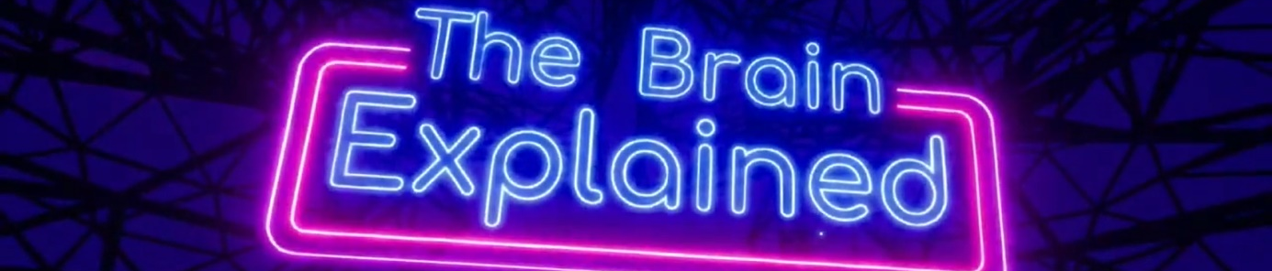
Prompts for facilitating discussion (refer back to a case study in this section)
- What did you hear in this film?
- Does this film help you understand your young person more?
- What might the risk-taking behaviours look like?
- What do you think your young person’s “planes” are?
- Follow up questions: How might you support your young person with guiding/prioritising their “planes”?

- THE CONNECTED BRAIN
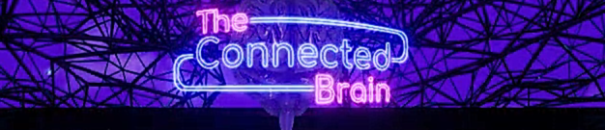
Prompts for facilitating discussion with parents/carers
- What was it like to be a teenager? Take time to reflect on your experiences.
- What does your young person like to do?
- Do you talk to your young person about their feelings/stresses?
- How do you feel about difficult conversations with your young person? What might help you? Do you see a benefit in talking about these things?
- Did you know that early life experiences impact how our brain develops? (Discussion point and reflections).

Resources/further reading
https://www.youngminds.org.uk/young-person/coping-with-life/trauma/

