JOURNEY INTO CARE THROUGH THE CHILD’S EYES
For professionals

Objectives
- Use the VR films to walk participants through a child's journey into care.
- Increasing understanding and using a reflective space to consider our roles in supporting children in care

Film
- Fostering

- FOSTERING
A child talks about their experience of coming into care.
Health warning! Please remind viewers of the emotive nature of this film and that they can come out of headsets at any time.
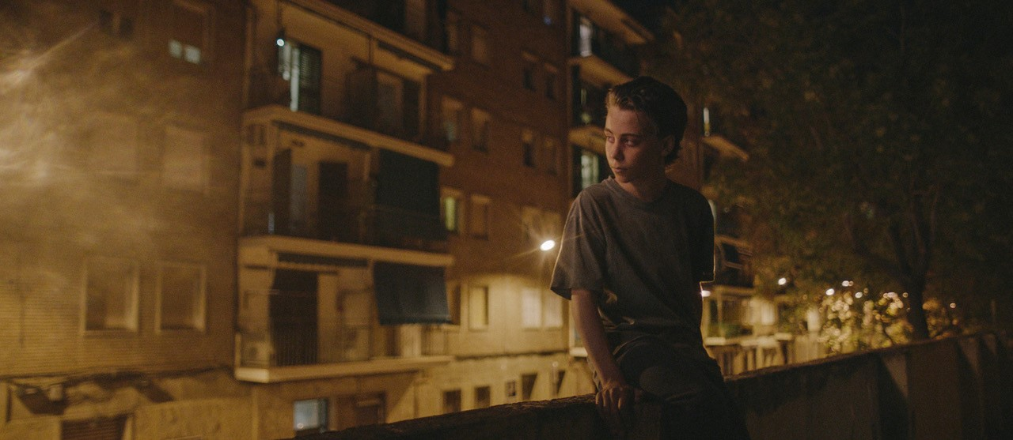
Prompts for facilitating discussion with professionals
- What did you see, hear and feel?
- Are there any feelings that you weren’t expecting?
- What are the key issues you observed?
- What impact would these early life experiences have on this child?
- What behaviours and emotional responses do you think they might demonstrate?
- What might that look like for the child at ages 4/8/12/16?
- As a professional how do you think you can work with and support children who have come into care?

