EXPLORING YOUTH VIOLENCE AND OUTCOMES
For young people
Objectives
- Understand what impacts on the decisions we and others make
- Increase our understanding of social issues young people face today
- Increase our self-awareness and understand the outcomes of our own responses
- Consider how to equip young people with strategies that can be used in heightened situations

Films & Resources
- House Party – was it you?*
- House Party – It's not worth it
- Danny and Omari’s character life journey

- HOUSE PARTY- WAS IT YOU?
*Health warning! The film you are about to watch contains scenes viewers may find difficult.
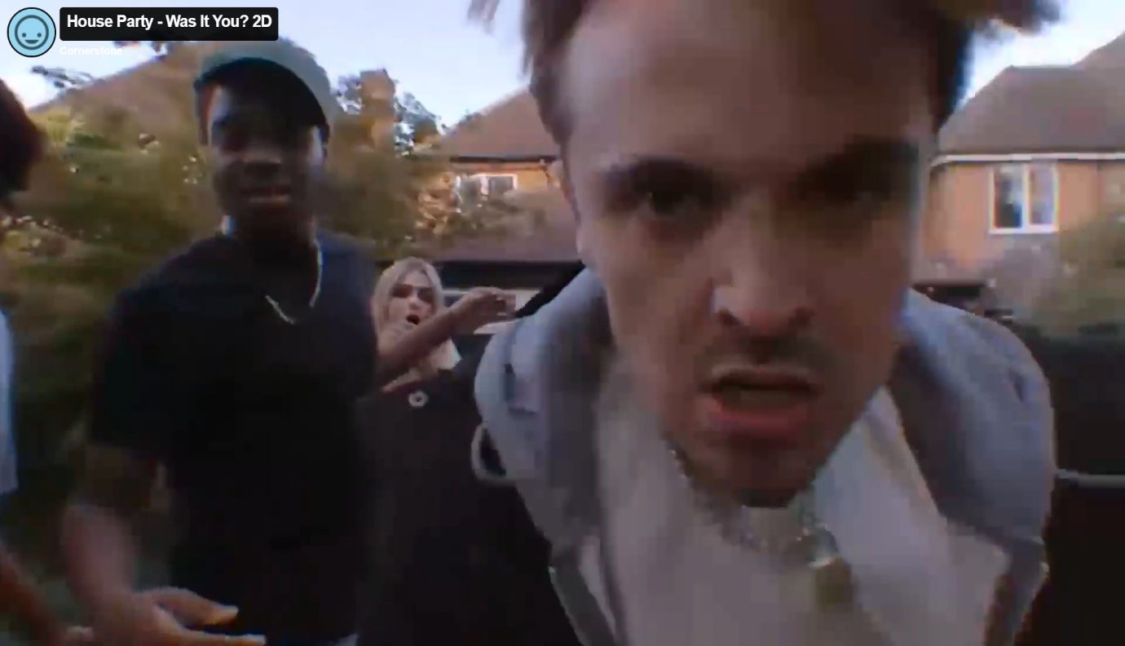
Prompts for facilitating discussion with young people
You may want to break this session into parts, move the questions around depending on the needs of those you’re delivering to.

- What happened?
- How did you feel?
- What did you notice about your body’s response to this situation? (PROMPT: heart racing, wanting to run, clenched fist, etc)
- PROMPT FOR DELIVERERS: REFER TO BRAINS REPONSE TO DANGER
- What helps you to calm when in danger/scary space?
- Do you think this situation could have been de-escalated at any point?
- What might this look like?
- What stood out for you?
- What do you think influences someone to be in Danny and Omari’s position? (provide character story)
- What would you have expected from your friends prior to the incident?
- What options/choice do you think the party people had in this situation?
- What do you think happens next?
- What could anyone have done differently?
- What is the impact on others?
- What would happen next? What are the legal implications, how would the police, legal system get involved, are you aware of joint enterprise?

- HOUSE PARTY- IT’S NOT WORTH IT:
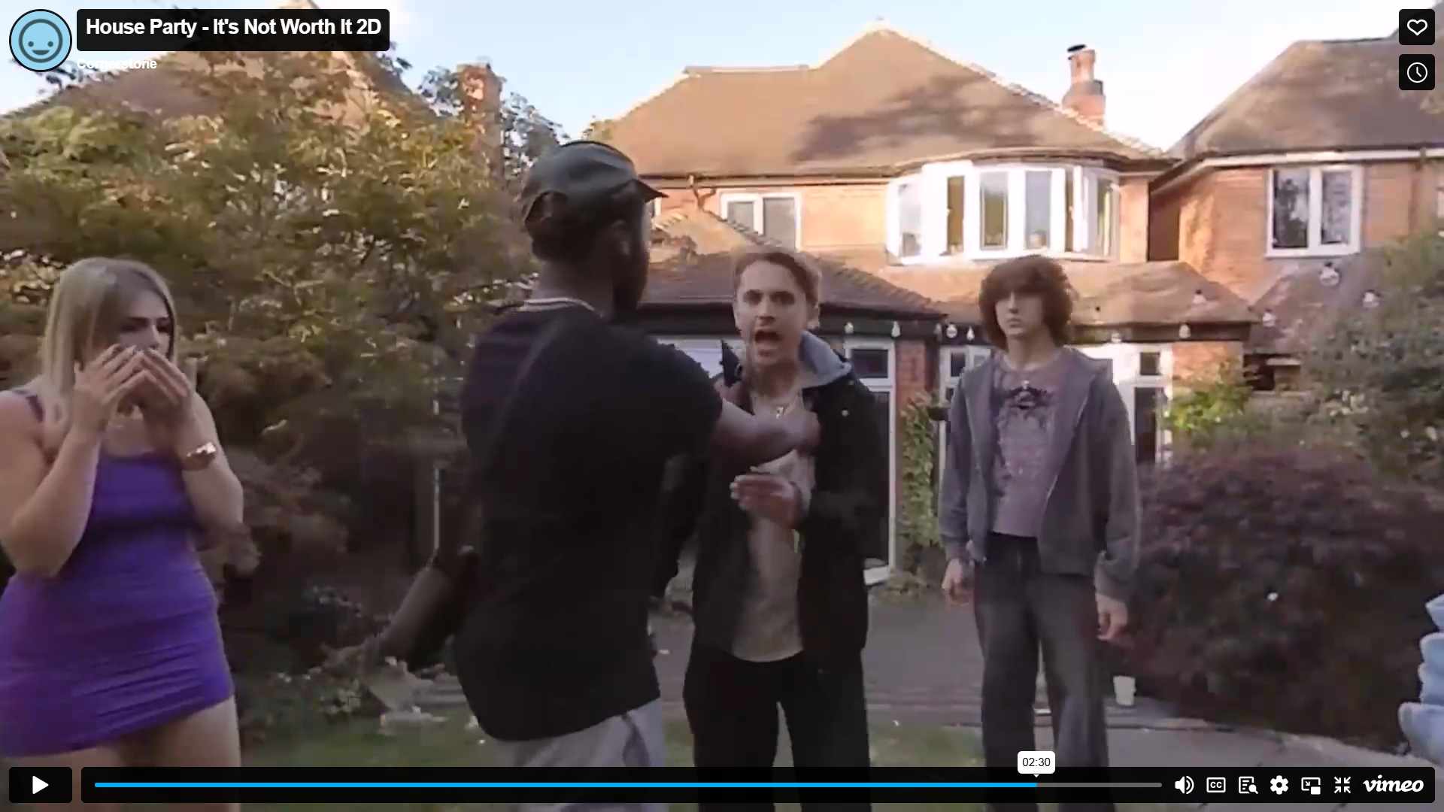
Prompts for facilitating discussion with young people
- What happened?
- What options/choice do you think the party people had in this situation?
- What do you think made Omari intervene? Is this something you could/would do?
- Would there be any repercussions for intervening for Omari?
- What do you think happens next?
- What could anyone have done differently?
- What is the impact on others?

Resources
England: https://lawstuff.org.uk/police-and-law/what-can-happen-to-me-if-i-break-the-law/
Scotland: https://www.cycj.org.uk/resource/youthjusticeinscotland/
Wales: https://safercommunities.wales/offending-justice/youth-justice-system/

