EXPLORING YOUTH VIOLENCE AND OUTCOMES
For parents & carers
Objectives
- Understand what impacts on the decisions we and others make
- Increase our understanding of social issues young people face today
- Increase our self-awareness and understand the outcomes of our own responses
- Consider how to equip young people with strategies that can be used in heightened situations

Films & Resources
- House Party – was it you?
- House Party – It's not worth it
- Danny and Omari’s character stories

- HOUSE PARTY - WAS IT YOU?
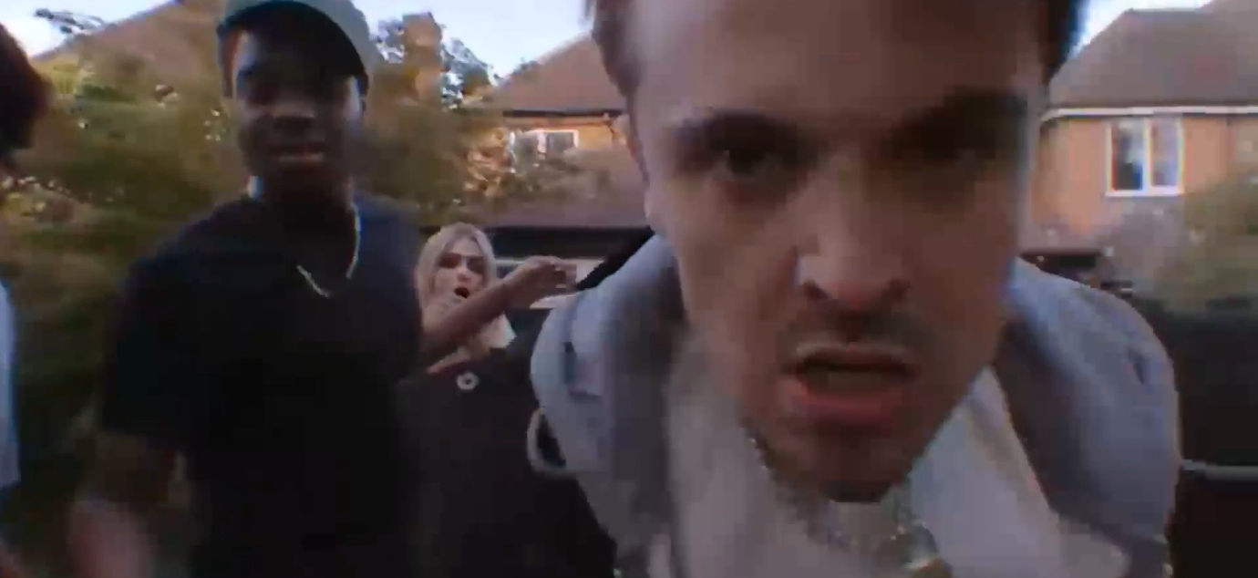
Prompts for facilitating discussion with parents/carers
- How did this make you feel?
- Did you want to fight? Flight? Freeze?
- What would you do in this situation?
- How did you self-regulate?
- Do you speak to your child about any incidents that happen around you?
- What do you think your child would do in this situation?
- How confident do you feel to speak to your child about what’s happening in your area?
- Are you aware of the legal implications of carrying a knife? Joint enterprise?
- How do you discuss these issues with your child?

- HOUSE PARTY- IT’S NOT WORTH IT
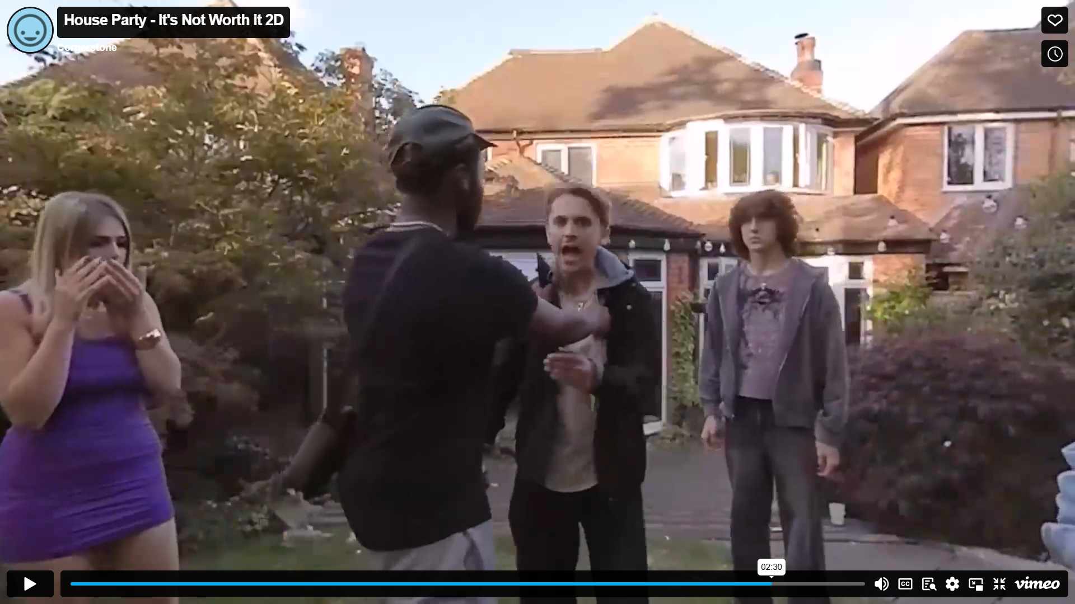

Prompts for facilitating discussion with parents/carers
Before watching the film:
- Do children always tell their adults if they’re going to a party?
- What do you think helps children to be open with their adults about what they’re doing away from them?
- What pressures do you think children are experiencing in today's society?

After watching the film:
- What societal pressures did you and those at the party experience?
- What do you think enabled Omari to support his friend from making a bad decision?
- What impact do you think this situation may have on a child?
- What might you recognise in your child if they’d been to a party and this incident had happened?
- How might you talk to your child about this?
- Do you feel able to talk to your child about their mental health?

Resources
- England:
https://lawstuff.org.uk/police-and-law/what-can-happen-to-me-if-i-break-the-law/
- Scotland:
https://www.cycj.org.uk/resource/youthjusticeinscotland/
- Wales:
https://safercommunities.wales/offending-justice/youth-justice-system/

