EXPLORING YOUTH VIOLENCE AND SOCIETAL PRESSURES
For young people
Objectives
- To help young people understand how their brain is developed and operates, and impacts their feelings and their actions
- To understand external factors that may impact how we are feeling
- Awareness about how we feel about our communities in real life and in the digital world
- Understand what impacts on the decisions we and others make

Films
- Bus Stop – What You Got?
- Introduction to the Digital World
- At Home - I texted You
- Welcome to the Teenage Brain

- BUS STOP- WHAT YOU GOT?
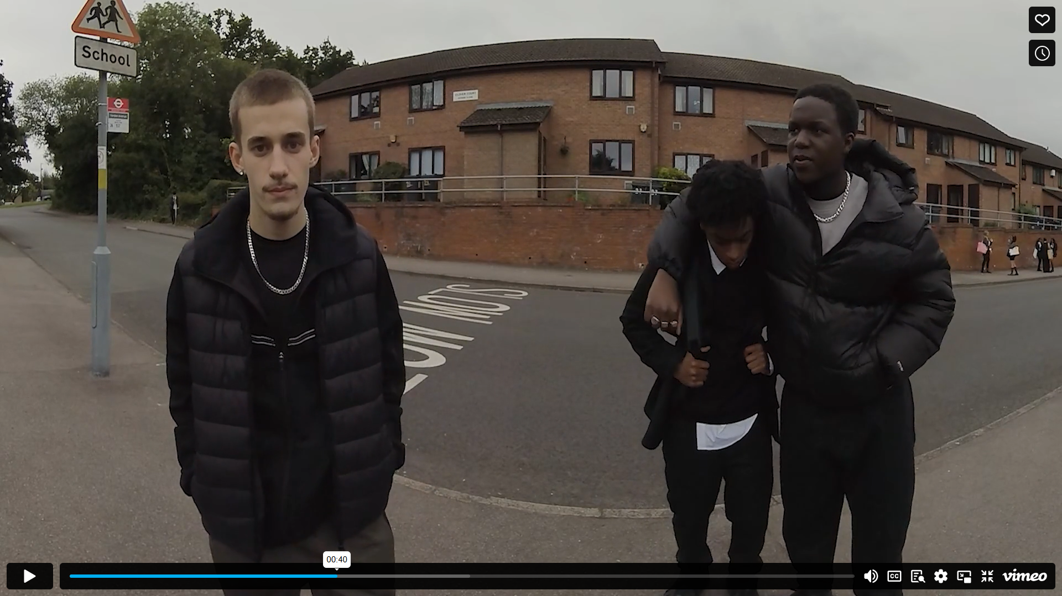

Prompts for facilitating discussion with young people
- How did you feel?
- Does this happen near you?
- What do you think Kayden was feeling?
- What would you do in this situation? Reflect on response
- What do you think influences someone to be in Jamie and Michaels position? (provide character story)
If working in groups, consider the following:
- Thinking about ‘you’– how do you think they are feeling after this altercation?
- Thinking about your friend Kaden – how do you think he is feeling after this altercation?
- Thinking about the two girls – how do you think they are feeling?
Feedback from each group focussing on a different point.

- INTRODUCTION TO THE DIGITAL WORLD
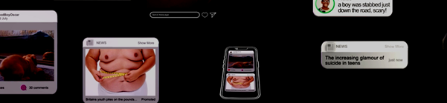
Prompts for facilitating discussion with young people
- What do you think? How similar is this to you and your friend’s digital world?
- Do you ever see arguments online?
- How do you think people involved in these arguments are feeling?

ACTIVITY - On a piece of paper:
- Draw a circle on the paper and divide this into how much of the social media viewed in this film is positive/negative/neutral.
- Divide how much social media is from friends/family - those you live with -strangers
- If this was your friend do you think that is a ‘healthy’ split?
- What would you tell a friend to do to make it friendlier/safer/happier for them online.

- AT HOME - I TEXTED YOU
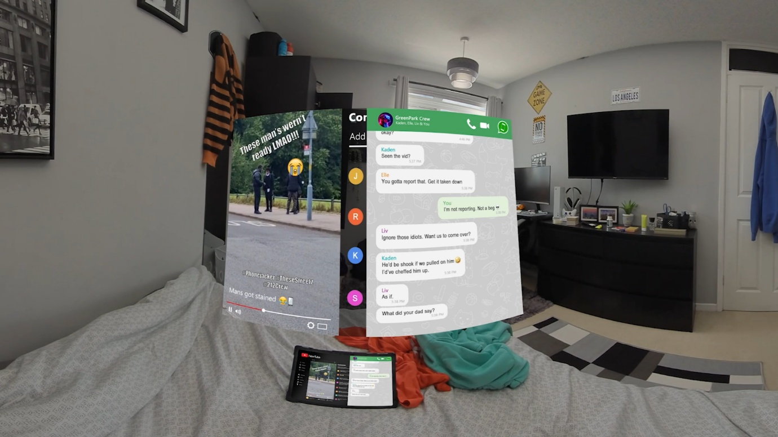
Prompts for facilitating discussion
- What do you notice happening within this film?
- What impact do you think this has had on ‘you’
- Can you relate to any of the messages in this film?
- What makes a healthy relationship, online and off line?

- WELCOME TO THE TEENAGE BRAIN
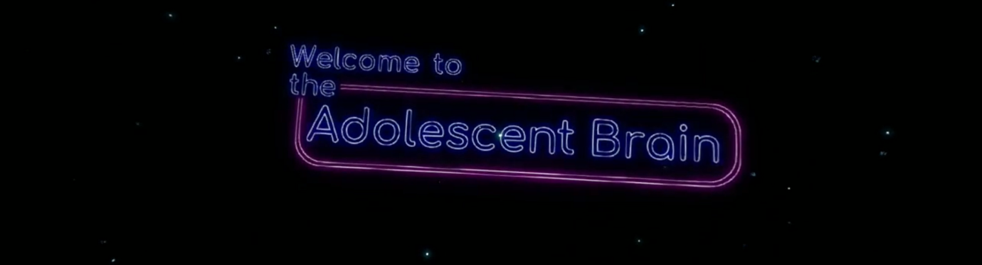
Prompts for facilitating discussion with young people
- What are your thoughts on the age of brain development? Did anything stand out for you?
- What does support look like for you (think who and where)?

Resources
https://benkinsella.org.uk/resources-for-teachers-and-practitioners/

https://crimestoppers-uk.org/fearless/professionals/resources

Knife Crime – Safe4Me

