EXPLORING YOUTH VIOLENCE AND SOCIETAL PRESSURES
For professionals
Objectives
- To understand external factors that may impact how we are feeling
- Awareness about how we feel about our communities in real life and in the digital world
- Understand what impacts on the decisions we and others make

Films
- Bus Stop – What You Got?
- Introduction to the Digital World
- At Home - I texted You
- Welcome to the Teenage Brain

- BUS STOP- WHAT YOU GOT?

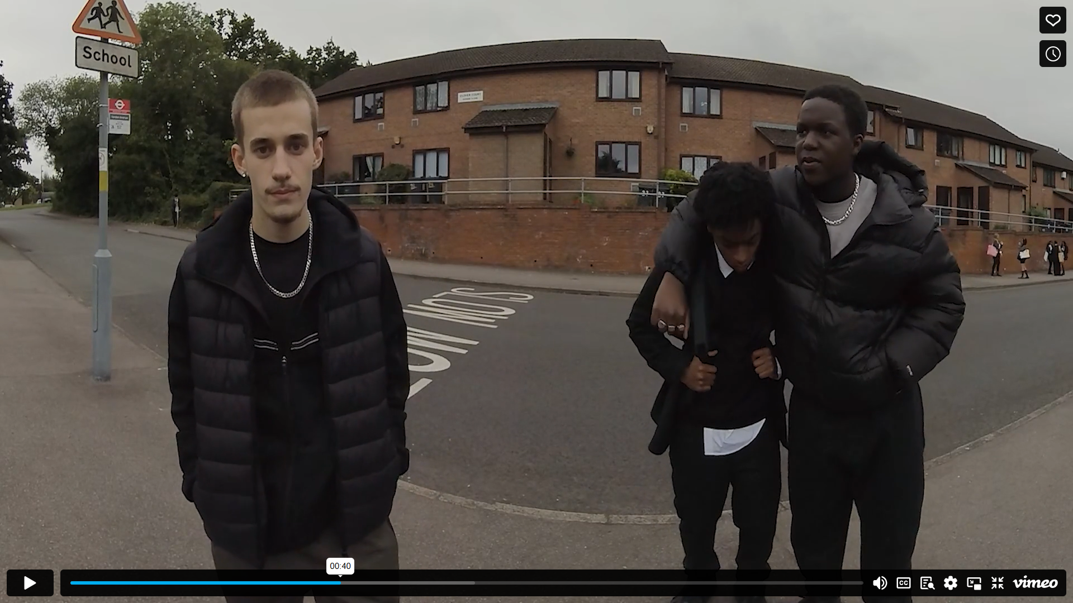
Prompts for facilitating discussion with professionals
- How did you experience this film?
- Is there a child you’re supporting who’s been a part of this situation? Which character were they?
- Do you consider Jamie to be vulnerable?
- What influences Jamie’s decision to carry? (Read character’s story).
- Do you know your services response to your local knife crime strategy?
- How is this communicated to staff?

- INTRODUCTION TO THE DIGITAL WORLD
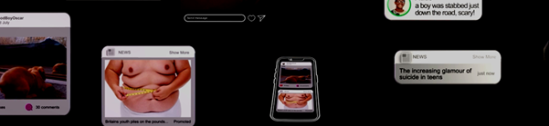
Prompts for facilitating discussion with professionals
- What is the impact of the digital world on the child/ group you support?
- How do you explore this with them?
- Do you feel confident in holding a conversation about this? If not, what might be the barriers for you?
- How do you use tech to engage/ support your children, look at the positives to support your relationships

- AT HOME - I TEXTED YOU
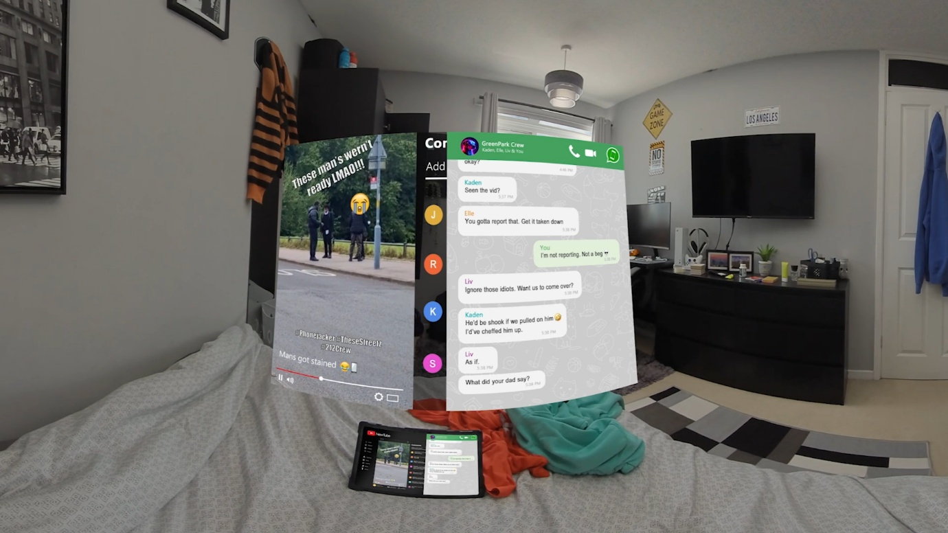
Prompts for facilitating discussion
- What do you notice happening within this film?
- What impact do you think this has had on ‘you’
- Can you relate to any of the messages in this film?
- What makes a healthy relationship?

- WELCOME TO THE TEENAGE BRAIN

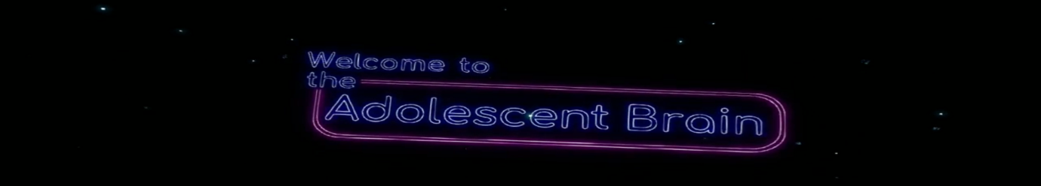
Prompts for facilitating discussion with professionals
- What were your thoughts about the age of brain maturity? How would your expectations differ now that you know that? Has this changed your views or expectations of young person?
- How might you support and guide your young person?

Prompts for facilitating discussion with professionals – Activity suggestions
- With the play dough/ string mould a brain.
- Visualising child’s tasks as aeroplanes, as an air traffic controller what does your young person do well, and what do they need more structured/support with to build resilience.
- What are the barriers and what realistic changes need to be made to support your intervention/ services.

Resources
https://benkinsella.org.uk/resources-for-teachers-and-practitioners/

https://crimestoppers-uk.org/fearless/professionals/resources

Knife Crime – Safe4Me

