ENHANCING TRAUMA INFORMED RESPONSES
For professionals

Objectives
- To increase knowledge of trauma informed responses
- To provide real-life scenarios that aid parents/carers/professionals in increasing their self-awareness
- To raise awareness of self-care, and aid participant to increase this in their lifestyle
- To increase confidence in participants supporting vulnerable children and young people

Films
- The Unborn Child’s View
- Carnaby Street* / Colmore Road
- School Triggers
- Style A – School
- Style B – School
- Therapeutic Approach – At School
- Style A – Home
- Style B – Home
- Therapeutic Approach – At Home

- THE UNBORN CHILD’S VIEW
In this film of Rayleigh in-utero, we see the impact of domestic abuse and substance misuse.
*Health warning! Please remind viewers of the emotive nature of this film and that they can come out of headsets at any time.
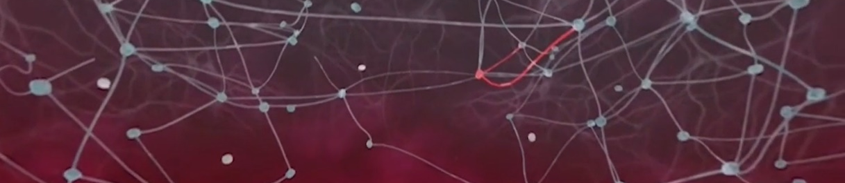
Prompts for facilitating discussion with professionals
- How did you find watching that film?
- What were some factors you noticed impacting on the unborn child?
- How might watching this film impact on your assessment skills? When thinking about assessments, what are all the risks that need to be considered? What would need to happen to mitigate the identified risks?
- How would you capture the unborn child’s voice in the assessment?
- What’s your understanding about sensory memories?
- Think about the children and young people you’re working with and what we know about their pre-birth experiences. Does this film help you understand their world better?

Resources/further reading
https://learning.nspcc.org.uk/child-health-development/childhood-trauma-brain-development/

- CARNABY STREET
In this film we experience the impact of abandonment, neglect, abuse and shaming, through the eyes of 18-month-old Rayleigh.
*Health warning! Please remind viewers of the emotive nature of this film and that they can come out of headsets at any time.
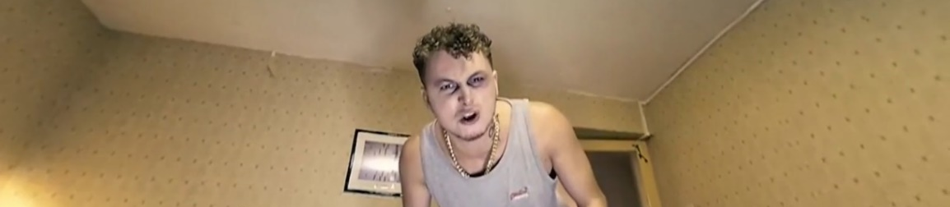
Prompts for facilitating discussion with professionals
- What are the key issues you observed?
- What is the impact on the child’s brain development?
- What impact would these early life experiences have on this child? What behaviours and emotional responses do you think they might demonstrate?
- What might that look like for the child at ages 4/8/12/16?
- Does the age of the child change your risk assessment?
- Does the risk assessment explore the adult’s role as a carer for a child, as well as the adult’s individual needs?
- What support can you put in place for the child?
- Did you notice the television disappearing through the film? What could this mean?

Resources/further reading
- learning-from-case-reviews-parents-substance-use.pdf (www.nspcc.org.uk)
- https://learning.nspcc.org.uk/child-abuse-and-neglect/domestic-abuse
- https://learning.nspcc.org.uk/child-abuse-and-neglect/neglect/

3. SCHOOL TRIGGERS INTRODUCTION
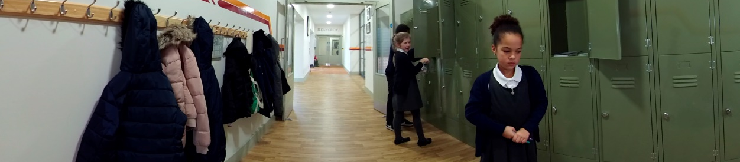

Prompts for facilitating discussion with professionals
- What did you notice about Rayleigh’s brain?
- What triggers did you notice Rayleigh experience? How does this link to her early experiences?
- What do you notice about her interaction with the children?
- What impact would this have on her feelings of safety and ability to learn at school? What impact does this have on her life?

- RAYLEIGH AT SCHOOL: STYLES A & B

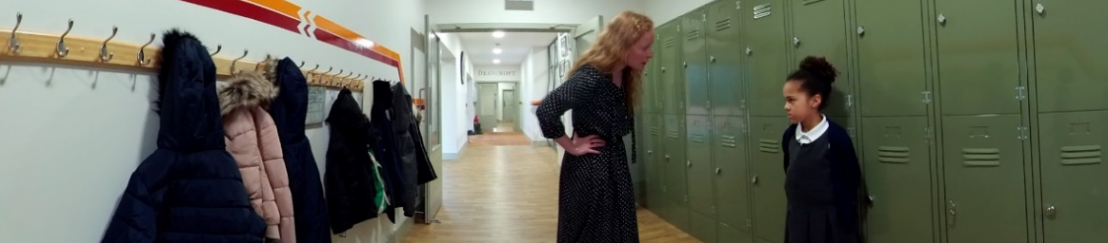
Prompts for facilitating discussion with professionals
- What did you notice in this film? What stood out for you?
- Compare the two responses. What worked well and what did not work well?
- What did you notice about the teacher in experience A? How did that impact Rayleigh? (Think yelling; instantly blamed Rayleigh; didn’t listen; unsafety).
- What did you notice about the teacher in experience B? How did that impact Rayleigh?
- Does Rayleigh feel supported?
- Do you think the teacher would have managed it differently if they knew about her early experiences? If so, why does that make a difference?

- RAYLEIGH AT SCHOOL – THERAPEUTIC APPROACH

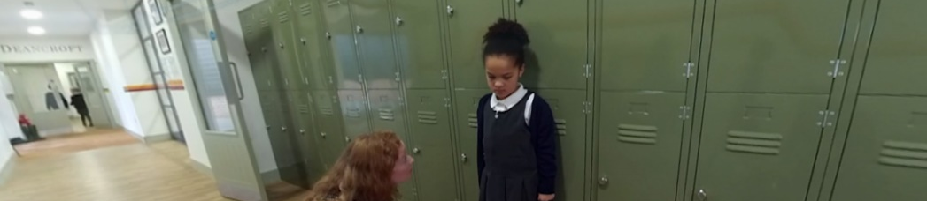
Prompts for facilitating discussion with professionals
- What did you notice about the teacher’s therapeutic approach? How did that impact Rayleigh?
- How was Rayleigh supported by the interaction?
- How would Rayleigh be feeling following that interaction?
- What measures can be introduced to support Rayleigh at school?
- How would we record the incident?

- RAYLEIGH AT HOME – STYLES A & B
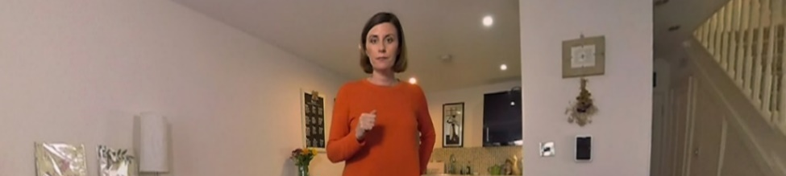
Prompts for facilitating discussion with professionals
- What did we observe during the interactions?
- What styles of parenting were observed? How did each style impact on Rayleigh?
- If all behaviour is communication, what was the carer communicating to Rayleigh?
- What were the negatives and positives of the interaction?
- Given the knowledge about Rayleigh’s early life experiences, what is likely to trigger Rayleigh during this interaction with her carer?

- RAYLEIGH AT HOME – THERAPEUTIC APPROACH
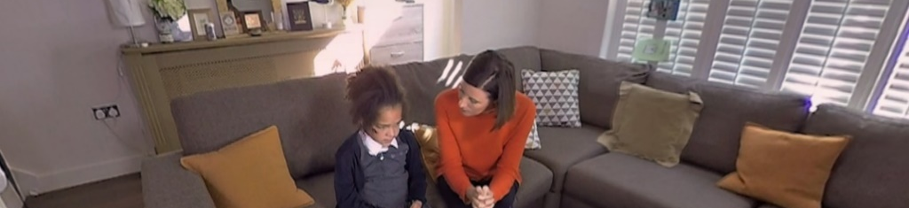
Prompts for facilitating discussion with professionals
- What did we notice about this style of interaction?
- How did Rayleigh respond?
- How could we support Rayleigh’s home life?
- What would you like to see included in Rayleigh’s assessments/EHC plan?
- How would you interact with Rayleigh?
- What are the key messages being given to Rayleigh? What is the likely impact of these messages in her life?

