CHILD SEXUAL EXPLOITATION
For young people
Objectives for Young People
- Enable professionals to develop relationships with young people who are at risk of and being sexually exploited.
- To discuss consent, healthy relationships and the risks of CSE with young people
- To help young people identify their vulnerability.
- To discuss alternative, less risky behaviours with young people.

Films
- Introduction to Aisha
- Aisha A
- Aisha B
- Aisha Child Sexual exploitation*
- Aisha Disclosure

- AISHA INTRODUCTION
In this film, we see various things that may make Aisha scared, vulnerable and isolated. Please allow some time for silent reflection to allow for your participants to process the films.
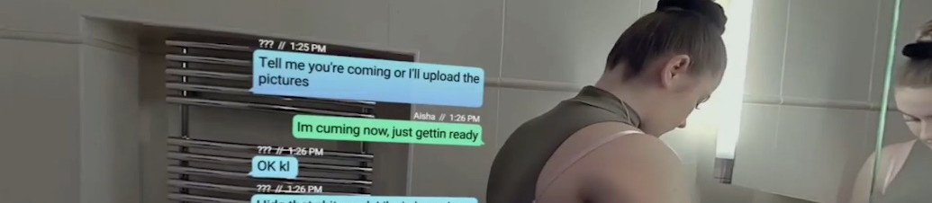
Prompts for facilitating discussion with young people
- How might Aisha be feeling?
- Is it OK to receive a text like this from someone you are in a relationship with?
- Who can Aisha talk to? Would she feel comfortable talking to a parent/carer/worker?
- What choice do you think Aisha has?
- Do you think she knows what her choices are?

- AISHA A
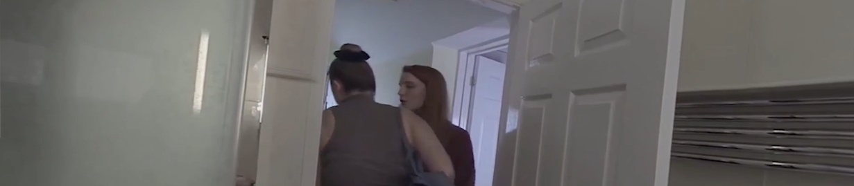
Prompts for facilitating discussion with young people
You may wish to start a discussion with young people about how early negative experiences, such as domestic abuse, may influence peer relationships.

- What do you notice happening for Aisha?
- What do you think a young person would need from their carer at this point?
- How do you think Aisha is feeling?
- If Aisha could not go to her parent/carer, who else could she reach out to for support?

- AISHA B
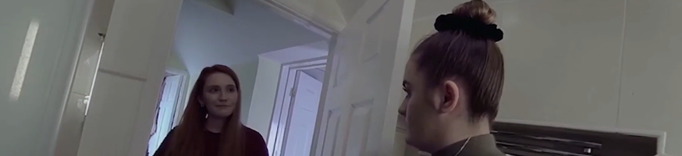
Prompts for facilitating discussion with young people
- Was the carers response helpful?
- How do you think Aisha is feeling?
- What advice would you give parents/carers regarding talking to their child about relationships?

- AISHA - CHILD SEXUAL EXPLOITATION
*Health warning! The film you are about to watch contains scenes viewers may find difficult.
Different discussion points: This session plan can cover a number of topics with young people and their support network(s). We have given you some options to consider. Always think about what your objective is for your participants.

First session: prompts for facilitating discussion with young people
Discuss consent in relation to sex. What is consent? Can consent be withdrawn at any point during a sexual encounter?

- How do you think Aisha is feeling?
- What is happening for the girl in the bed?
- What are the men in the bedroom thinking? What advice would you give to them?

Second session: prompts for facilitating discussion with young people
The film above covers topics of rape and human trafficking. It might be that you are wanting to cover a session that educates young people around these topics, so that they can make informed decisions.

- In the film, Aisha is under the influence of alcohol. Does she have capacity to consent?
  - Prompt. No, she does not, because she is intoxicated, therefore she’s unable to give consent. In this instance it is always rape and being in a relationship does not give automatic consent.
- Do you know what rape is?
- Aisha’s boyfriend has brought Aisha to the party to exploit her. Do you know how Aisha has been exploited?
- Do you know about human trafficking?
- Do you think Aisha has been trafficked?
- How would you describe a healthy relationship?

- AISHA DISCLOSURE
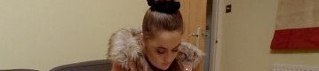
Prompts for facilitating discussion with young people
- What do you think helped Aisha to talk to her carer about being sexually exploited?
- What do you think young people need from their key people (e.g. parents/carers/teachers/coaches) to help them have difficult conversations such as talking about someone sexually exploiting them?

Resources/further reading
- https://www.childline.org.uk/info-advice/friends-relationships-sex/sex-relationships/sex-consent/
- https://www.youtube.com/watch?v=pZwvrxVavnQ
- https://www.youtube.com/watch?v=1oyE-qE4340
https://www.uobcsepolicinghub.org.uk/assets/documents/RBF-2-Pearce-Short-video-briefing-paper.pdf
- https://www.childline.org.uk/info-advice/friends-relationships-sex/sex-relationships/healthy-unhealthy-relationships/
- https://www.nspcc.org.uk/what-is-child-abuse/types-of-abuse/child-trafficking/#what
https://www.childline.org.uk/info-advice/bullying-abuse-safety/abuse-safety/rape-sexual-assault/

