CHILD SEXUAL EXPLOITATION
For parents & carers
Objectives for Parents & Carers
- Enable parents/carers to experience the world of a CYP exposed to CSE.
- To help parents understand the dangers CYP are exposed to/at risk of, in relation to CSE.
- To support parents/carers to keep their children safe.
- To open up a conversation with a young people about their risk of CSE.
- To help young people identify their vulnerability.
- To discuss alternative, less risky behaviours with young people.

Films
- Introduction to Aisha
- Aisha A
- Aisha B
- Aisha Child Sexual exploitation*
- Aisha Disclosure

- AISHA INTRODUCTION
In this film, we see various things that may make Aisha scared, vulnerable and isolated. Please allow some time for silent reflection to allow for your participants to process the films.
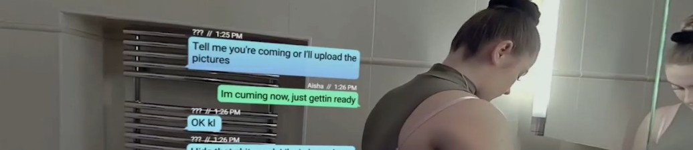
Prompts for facilitating discussion with parents/carers
Remember! This part is for your participants to feel supported and empowered in their learning. We are not wanting parents/carers to feel judged or shamed.

- What would your response be if you saw messages like this on your child’s phone?
- What do you think they mean?
- How might Aisha be feeling?
- What do you think about the carer’s behaviour? Do you think Aisha feels comfortable to talk to her carer?
- What choice do you think Aisha has?
- Do you think she knows what her choices are?

- AISHA A
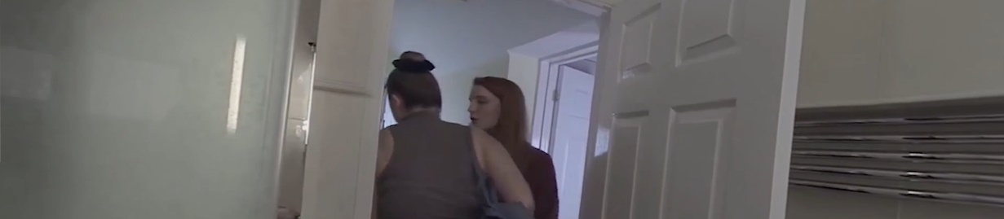

Prompts for facilitating discussion with parents/carers (adapt questions appropriately for your group). You may wish to refer to Aisha’s life journey in this section
As a carer, you need to be curious about changes in behaviour. Discuss how they approach a young person when they are curious about changes in behaviour.

- What was going on for the carer?
- What do you think would have helped Aisha in this moment? What does she need from her carer?
- How do you think Aisha is feeling?
- How do you think Aisha's past trauma links to her current situation?

- AISHA B
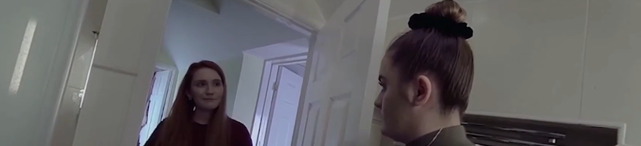

Prompts for facilitating discussion with parents/carers (adapt questions appropriately for your group)
- What did you observe happening?
- What worked well in this film?
- How did the carer work to form a connection with Aisha?
- What changes did you notice in Aisha's body language?
- What opportunities does this create for the young person and the carer’s relationship with them?

- AISHA - CHILD SEXUAL EXPLOITATION
*Health warning! The film you are about to watch contains scenes viewers may find difficult.
Different discussion points: This session plan can cover a number of topics with young people and their support network(s). We have given you some options to consider. Always think about what your objective is for your participants.
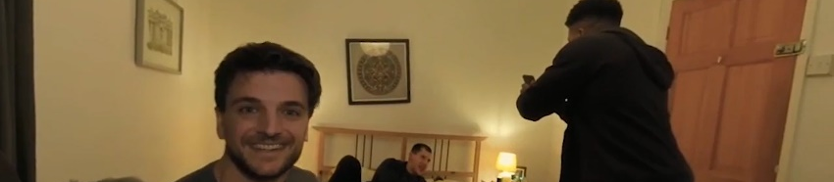

Prompts for facilitating discussion with parent/carers (adapt questions depending on group)
Prompt: Do the group you are talking to understand what a healthy relationship is? Consider resources available to you and to direct them to. It might be that participants in your group have had difficult relationships in the past and/or continue to be in one.

- How do you think Aisha is feeling?
- Do you feel confident or comfortable talking to your child about sex and consent?
- How would you describe a healthy relationship? How can we model it to young people?

Resources/further reading
- https://www.childline.org.uk/info-advice/friends-relationships-sex/sex-relationships/healthy-unhealthy-relationships/
- Did you see that coming? - YouTube

- AISHA DISCLOSURE
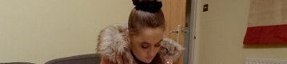

For parents/carers (adapt questions appropriately for group)
- How did the carer create space for Aisha to talk?
- How did she create safety for Aisha?
- What impact did it have on Aisha and the way she was feeling?
- How did the carer manage the disclosure?
- What would get in the way of you being able to respond to Aisha in this way?
- What would you do with the information Aisha shared?

