EXPLORING THE IMPACT OF EARLY LIFE TRAUMA ON YOUNG CHILDREN AT SCHOOL AND AT HOME
For professionals

Objectives
Use the VR to introduce participants to the pre-natal and early years experiences of children and young people who have experienced trauma to they can begin to understand and discuss how it may impact their lives.

Films
- Introduction: School Triggers
- Style A – School
- Style B – School
- Therapeutic Approach – At School
- Style A – Home
- Style B – Home
- Therapeutic Approach – At Home

- SCHOOL TRIGGERS INTRODUCTION
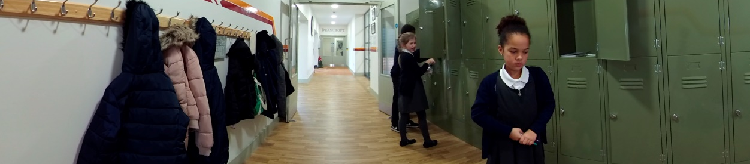

Prompts for facilitating discussion with professionals
- What did you notice about Rayleigh’s brain?
- What triggers did you notice Rayleigh experience? How does this link to her early experiences?
- What do you notice about her interaction with the children?
- What impact would this have on her feelings of safety and ability to learn at school? What impact does this have on her life?

- RAYLEIGH AT SCHOOL: STYLES A & B AND THERAPUTIC (watch all 3 at once)

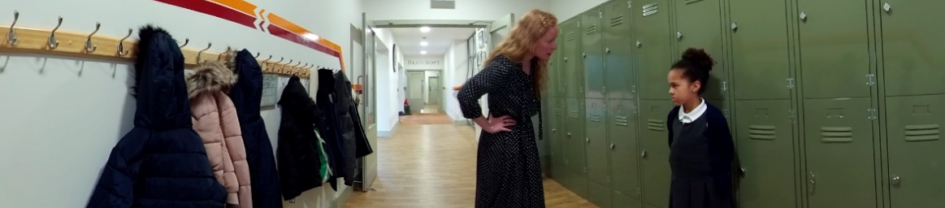
Prompts for facilitating discussion with professionals
- How might Rayleigh have experienced the last teacher compared to the first one? (In her body, in her thoughts, in her feelings, in her experience of safety?)
- What did you notice about the teacher in film A? How did that impact Rayleigh? (yelling, instantly blamed Rayleigh, didn’t listen, unsafe)
- What did you notice about the teacher in film B? How did that impact Rayleigh?
- What did you notice about the teacher in the Therapeutic approach? How did that impact Rayleigh? (body language, proximity, connection, listening, did not address behaviour of other children)
- If you were the teacher, how would you have managed that situation?
- Do you think they would have managed it differently if they knew about her early experiences?

- RAYLEIGH AT HOME – STYLES A & B AND THERAPUTIC (watch all 3 at once)
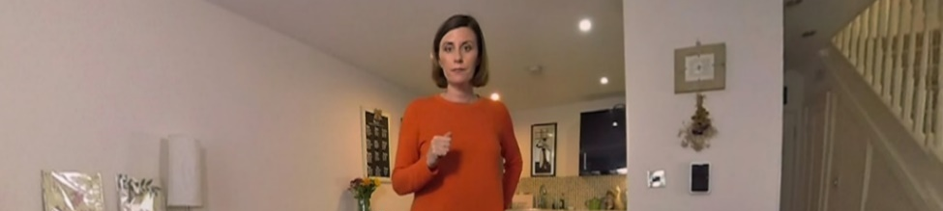
Prompts for facilitating discussion with professionals
- How was Rayleigh feeling at this point?
- What things do you need to consider? What is going on for her at this time?
- What was the carer feeling in this situation?
- What did the carer do that would have made Rayleigh feel unsafe, unseen and unsupported?
- What did you think the carer did well?
- What do you think would make a difference in this situation?
- How would you manage this situation?
- How would you help Rayleigh with her hygiene and hair care?
- What sort of things could you do outside of a crisis to reduce the intensity of this kind of situation? (Connection and development of relationship)

Consider:
- Rayleigh’s early experiences
- Belonging and identity
- Unable to ask for help
- Self esteem
- Trust in adults
- Fairness and Justice
- Does she feel lovable?
- Importance of safe adult relationships across all environments
- Impact of a trigger – lack of control or understanding about what is happening in her body
- Behaviour as communication
- Fear
- How much does the carer know? (Rayleigh’s experience, impact of trauma, impact of triggers)

