**VULNERABLE ADULTS AND CUCKOOING**

|  |
| --- |
| **Objectives** |
| * To increase knowledge around the exploitation of vulnerable adults. * Raise awareness of the signs and processes groomers might use. * To provide real life scenarios that aid participants in identifying risks and safety strategies. * Increase confidence in supporting vulnerable adults and young people at risk of/or being exploited. * Reflect on practice and opportunities to engage with vulnerable adults and young people when faced with barriers, such as control (i.e. that from perpetrators). |

|  |
| --- |
| **Audience** |
| * Practitioners * Carers * Adults considered to be vulnerable/at-risk |

|  |
| --- |
| **Guidance** |
| * This is a guide so you may not want to use/ask every question. Be guided by the group or individual. * Take action points away from this. What can you do with the information? * Take note of highlighted areas, as you can break these sessions down to run over several weeks/sessions. * Think about potential outcomes and be prepared to offer additional support, for example thinking about additional VR experiences for use in another session. |

|  |
| --- |
| **Preparation** |
| * Always prepare before delivery – i.e. what’s your objective? Are participants aware of what to expect? Do they know what VR is? Are they comfortable with you using VR with them? * Introduce VR. Talk about what “fully immersive” means, for example it puts you into the perspective of a person/child. 360-degree viewing allows you to see things from a different perspective. * Have you made participants aware of related health warnings, emotional (some videos contain distressing content and/or may cause feelings of anger/upset/fear) and physical (does the participant have any health issues that may be affected by using VR?). * Explain other pre-viewing tips (e.g. stay seated/freedom to remove headset at any point/ look around to get the full experience). * Explain the headset and controller. * Ensure access to evaluation and consent forms. * Follow up and continuation of learning from sessions is key to delivering change. |

|  |
| --- |
| **Closing the session/follow up** |
| * Complete evaluations. * Check in with the participant(s) about how they are feeling following the VR experience(s) and the conversations you have had. * Let them know who they can call for support, e.g. if anything comes up for them following the visit. * Let them know you will follow up with them within the following working week to check in following the visit. |

1. **ANGIE IN THE CAR (FILM IS REFERRED TO AS JOE IN CAR)**

|  |
| --- |
| **Prompts for facilitating discussion** |
| * What happened in this video? * Is this exploitation? If so, why? * How might Angie be feeling? * What risks do you think Angie may face? * What do you think might happen if Angie gets caught by the police? * What might happen if Angie loses the drugs/gets them taken away? * What would your advice to Angie be in this situation? * Who could Angie speak to about this? * Do you think Pete is displaying controlling behaviour? If yes, explain how. |

1. **ANGIE AND JOE IN THE TRAP HOUSE (FILM IS REFERRED TO AS JOE - GANGS/DRUGS IN TRAPHOUSE)**

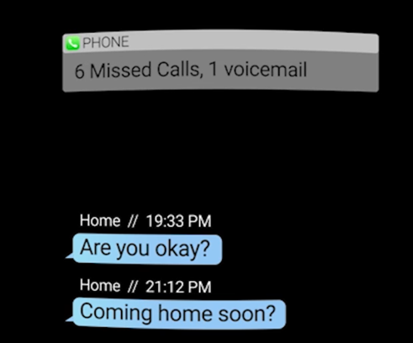

|  |
| --- |
| **Prompts for facilitating discussion** |
| * What is a “trap house”? * What is “cuckooing”? * Name five things that you’ve noticed. * What do you think Zac means by “the pharmacy is here for you now”? * Is Joe at risk? * Is Angie at risk? * What have you observed that makes Angie vulnerable? * How might you support them? * Is this exploitation? If so, who is being exploited in this video? * What could Joe do in this situation to keep himself safe? |

1. **ANGIE’S PROFILE**

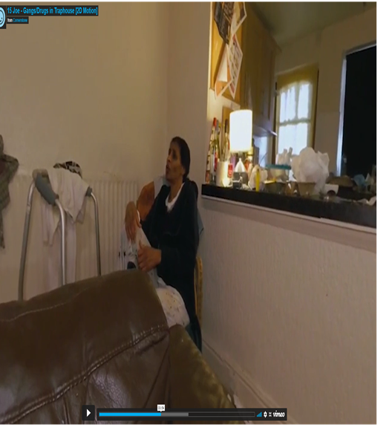

|  |
| --- |
| **Prompts for facilitating discussion** |
| * **Action:** Read Angie’s life journey document.   + Does this change your views now you have more detail?   + Do you think Angie has capacity to make informed decisions?   + How might you support Angie?   + Who would you contact?   + **Discussion point around professional duties:** If you’re the social worker/carer/housing officer for Angie, what are your duties towards Joe, and vice-versa? |