UNDERSTANDING THE ADOLESCENT BRAIN
Objectives
- To introduce participant(s) to VR.
- To support young people to understand how the adolescent brain works.
- To support professionals and parents/carers in understanding the impact of early-life trauma on brain development.
- To help parents/carers understand why teenagers take risks, whilst supporting parents/carers to think about the strengths/support that can be implemented.
- Harness the VR experiences to deepen understanding of the brain and the experiences of children and young people.

Target audience
- Young people
- Parents
- Carers
- Professionals

Guidance
- This is a guide so you may not want to use/ask every question. Be guided by your group.
- Take action points away from this. What can you do with the information?
- Take note of highlighted areas, as you can break these sessions down to run over several weeks/sessions.
- Think about potential outcomes and be prepared to offer additional support, for example thinking about additional VR experiences for use in another session.

Preparation
- Always prepare before delivery – i.e. what’s your objective? Are participants aware of what to expect? Do they know what VR is? Are they comfortable with you using VR with them?
- Introduce VR. Talk about what “fully immersive” means, for example it puts you into the perspective of a person/child. 360-degree viewing allows you to see things from a different perspective.
- Have you made participants aware of related health warnings, emotional (some videos contain distressing content and/or may cause feelings of anger/upset/fear) and physical (does the participant have any health issues that may be affected by using VR?).
- Explain other pre-viewing tips (e.g. stay seated/freedom to remove headset at any point/ look around to get the full experience).
- Explain the headset and controller.
- Ensure access to evaluation and consent forms.
- Follow up and continuation of learning from sessions is key to delivering change.

Closing the session and follow-up
- Complete evaluations.
- Check in with the participant(s) about how they are feeling following the VR experience(s) and the conversations you have had.
- Let them know who they can call for support, e.g. if anything comes up for them following the visit.
- Let them know you will follow up with them within the following working week to check in following the visit.

- WELCOME TO THE ADOLESCENT BRAIN
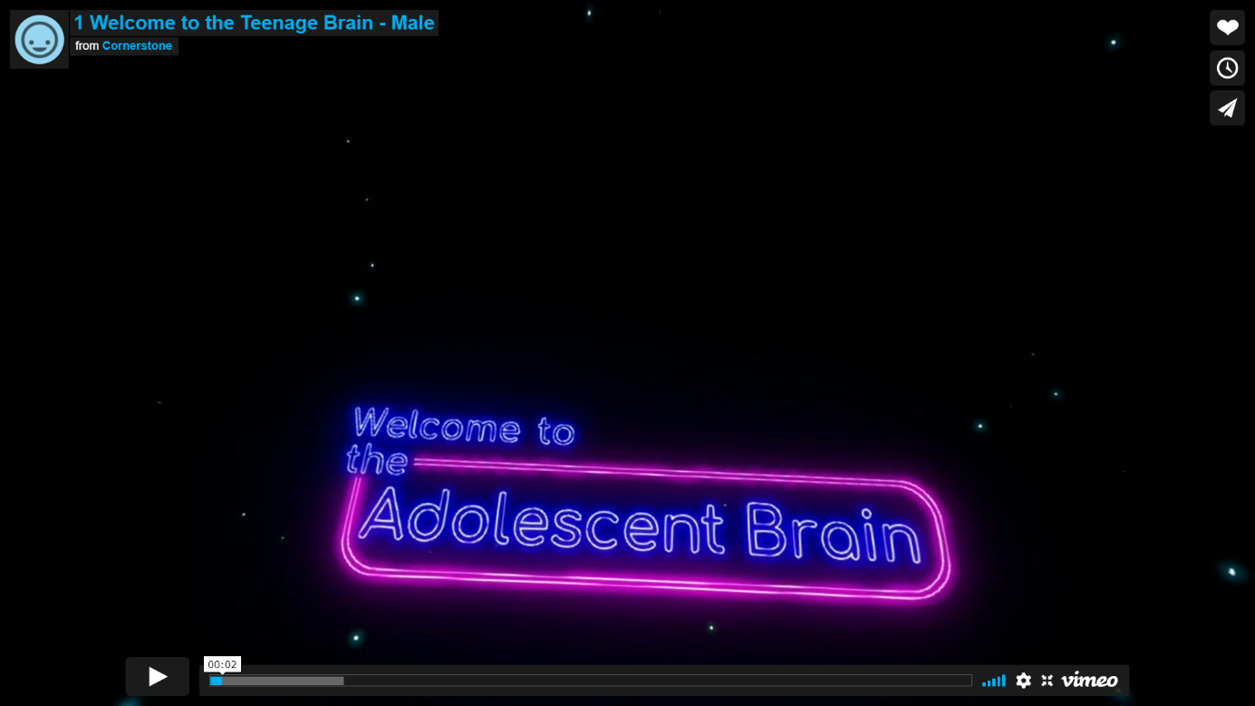
Prompts for facilitating discussion with young people
- What are your thoughts on the age of brain development? Did anything stand out for you?
- What does support look like for you (think who and where)?

Prompts for facilitating discussion with parents/carers
- What were your thoughts about the age of brain maturity? How would your expectations differ now that you know that? Has this changed your views or expectations of your young person?
- How might you support and guide your young person?

Prompts for facilitating discussion with professionals
- How might your expectations change, knowing your young person may not be able to recognise consequences immediately following their action(s)?
- What might you/your organisation need to do differently? What would that look like?

- THE BRAIN EXPLAINED
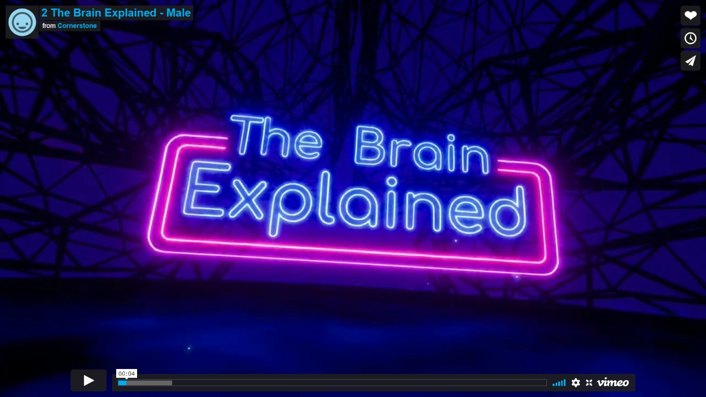
Prompts for facilitating discussion with young people
Prompt! You may wish to start a discussion with the young people about how early negative experiences, such as domestic abuse, may influence peer relationships.

- What did you understand from this film?
- What might risk-taking behaviours look like?
- What are your “planes”?

Prompts for facilitating discussion with parents/carers (refer back to case study in this section)
- What did you hear in this film?
- Does this film help you understand your young person more?
- What might the risk-taking behaviours look like?
- What do you think your young person’s “planes” are?
- Follow up questions: How might you support your young person with guiding/prioritising their “planes”?

- THE CONNECTED BRAIN
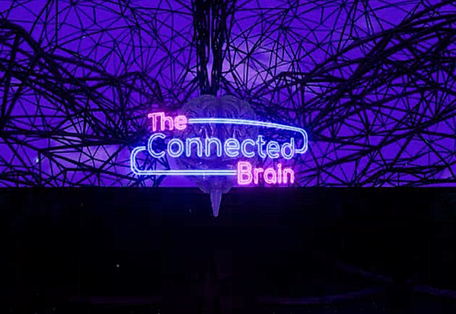
Prompts for facilitating discussion with young people
- What does it feel like to be a teenager? (Positives and negatives).
- Who can you talk to when feeling stressed/unhappy/sad/excited/nervous/ angry?
- Did you know that early-life experiences impact on how our brain develops? (Discussion point and reflections).
- Using the film to understand the people in the young person’s network, who they are and why they are important will help you (the professional) think about who should be involved in the young person’s plan.

Prompts for facilitating discussion with parents/carers
- What was it like to be a teenager? Take time to reflect on your experiences.
- What does your young person like to do?
- Do you talk to your young person about their feelings/stresses?
- How do you feel about difficult conversations with your young person? What might help you? Do you see a benefit in talking about these things?

Prompts for facilitating discussion with professionals
- Did you know that early life experiences impact how our brain develops? (Discussion point and reflections).
- How do you feel about difficult conversations with your young person? What might help you? Do you see a benefit in talking about these things?
- What protective factors can you build into your young person’s life?

Resources/further reading
https://www.youngminds.org.uk/young-person/coping-with-life/trauma/

