**THE IMPACT OF EARLY LIFE TRAUMA AT SCHOOL AND HOME**

|  |
| --- |
| **Objectives** |
| * To increase knowledge of trauma-informed responses. * To provide real-life scenarios that aid parents/carers/professionals in increasing their self-awareness. * To raise awareness of self-care, and aid participant to increase this in their lifestyle. * To increase confidence in participants supporting vulnerable children and young people. |

|  |
| --- |
| **Audience** |
| * Parents * Carers * Family members * Professionals |

|  |
| --- |
| **Guidance** |
| * This is a guide so you may not want to use/ask every question. Be guided by your group. * Refer to Rayleigh’s case study to support parents in thinking about the impact of past experiences on a child’s development, particularly considering self-worth and the stability of relationships. * Take note of highlighted areas, as you can break these sessions down to run over several weeks/sessions. * Take action points away from this. What can you do with the information? * Think about potential outcomes and be prepared to offer additional support, for example thinking about additional VR experiences for use in another session. |

|  |
| --- |
| **Preparation** |
| * Always prepare before delivery – i.e. what’s your objective? Are participants aware of what to expect? Do they know what VR is? Are they comfortable with you using VR with them? * Introduce VR. Talk about what “fully immersive” means, for example it puts you into the perspective of a person/child. 360-degree viewing allows you to see things from a different perspective. * Have you made participants aware of related health warnings, emotional (some videos contain distressing content and/or may cause feelings of anger/upset/fear) and physical (does the participant have any health issues that may be affected by using VR?). * Explain other pre-viewing tips (e.g. stay seated/freedom to remove headset at any point/ look around to get the full experience). * Explain the headset and controller. * Ensure access to evaluation and consent forms. * Follow up and continuation of learning from sessions is key to delivering change. |

|  |
| --- |
| **Closing the session/follow up** |
| * Complete evaluations. * Check in with the participant(s) about how they are feeling following the VR experience(s) and the conversations you have had. * Let them know who they can call for support, e.g. if anything comes up for them following the visit. * Let them know you will follow up with them within the following working week to check in following the visit. |

1. **THE UNBORN CHILD’S VIEW**

In this film of Rayleigh in-utero, we see the impact of domestic abuse and substance misuse.

Health warning! Please remind viewers of the emotive nature of this film and that they can come out of headsets at any time.

|  |
| --- |
| **Prompts for facilitating discussion with parents/carers** |
| * How did you find watching that? * How are you feeling now? * What were some factors you noticed impacting on the unborn child? * How much did you understand about a baby’s developing brain and their experiences prior to being born? * Thoughts about safe sleeping advice. |

|  |
| --- |
| **Prompts for facilitating discussion with professionals** |
| * How did you find watching that film? * What were some factors you noticed impacting on the unborn child? * How might watching this film impact on your assessment skills? When thinking about assessments, what are all the risks that need to be considered? What would need to happen to mitigate the identified risks? * How would you capture the unborn child’s voice in the assessment? * What’s your understanding about sensory memories? * Think about the children and young people you’re working with and what we know about their pre-birth experiences. Does this film help you understand their world better? |

|  |
| --- |
| **Resources/further reading** |
| <https://learning.nspcc.org.uk/child-health-development/childhood-trauma-brain-development/> |

1. **CARNABY STREET**

In this film we experience the impact of abandonment, neglect, abuse and shaming, through the eyes of 18-month-old Rayleigh.

Health warning! Please remind viewers of the emotive nature of this film and that they can come out of headsets at any time.

|  |
| --- |
| **Prompts for facilitating discussion with parents/carers** |
| * How was the child in Carnaby St. feeling? * Do you know of anyone who has had a similar experience? * What impact would these early life experiences have on this child? What behaviours and emotional responses do you think they might demonstrate? * What might that look like for the child at ages 4/8/12/16? What challenges might this present? * How would you feel caring for a child who has experienced this? * What was the experience of the male caregiver? * What was the experience of the female caregiver? * How would you support this child’s contact and relationship with their parents? * How might this impact on their relationships? * If this child didn’t have food regularly, what impact might this have? * If this child was unable to have their emotional and safety needs met, what impact might this have? |

|  |
| --- |
| **Prompts for facilitating discussion with professionals** |
| * What are the key issues you observed? * What is the impact on the child’s brain development? * What impact would these early life experiences have on this child? What behaviours and emotional responses do you think they might demonstrate? * What might that look like for the child at ages 4/8/12/16? * Does the age of the child change your risk assessment? * Does the risk assessment explore the adult’s role as a carer for a child, as well as the adult’s individual needs? * What support can you put in place for the child? * Did you notice the television disappearing through the film? What could this mean? |

|  |
| --- |
| **Resources/further reading** |
| * [learning-from-case-reviews-parents-substance-use.pdf (nspcc.org.uk)](https://learning.nspcc.org.uk/media/w2eh34r1/learning-from-case-reviews-parents-substance-use.pdf) * <https://learning.nspcc.org.uk/child-abuse-and-neglect/domestic-abuse> * <https://learning.nspcc.org.uk/child-abuse-and-neglect/neglect/> |

**3. SCHOOL TRIGGERS INTRODUCTION**

|  |
| --- |
| **Prompts for facilitating discussion with parents/carers** |
| * What do we notice in this video? * What is happening for Rayleigh? * If you feel triggered, do you know what you can do to make yourself feel better/to self-regulate? * Can you describe how you might respond in that situation? * How would you support Rayleigh to understand what is happening for her?   **Task:** Complete the *Self-Care Wheel*. Did this feel easy to complete? Are the activities you’ve written down something that you can do easily? |

|  |
| --- |
| **Prompts for facilitating discussion with professionals** |
| * What did you notice about Rayleigh’s brain? * What triggers did you notice Rayleigh experience? How does this link to her early experiences? * What do you notice about her interaction with the children? * What impact would this have on her feelings of safety and ability to learn at school? What impact does this have on her life? |

1. **RAYLEIGH AT SCHOOL: STYLES A & B**

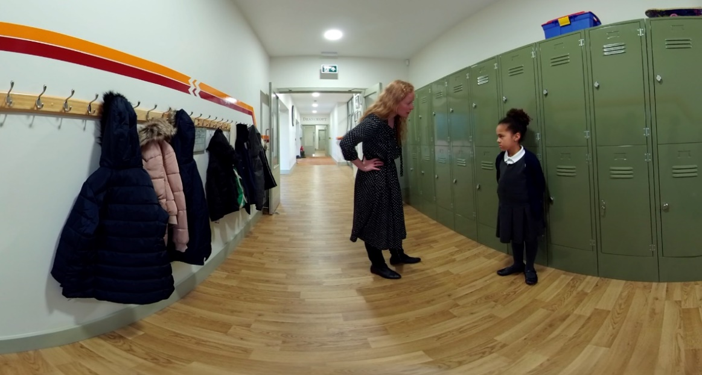

|  |
| --- |
| **Prompts for facilitating discussion with parents/carers** |
| * What is important for Rayleigh in this interaction? * What did you notice in this film? What stood out for you? * How was Rayleigh’s brain responding to the teacher? * What messages was she receiving within this interaction? |

|  |
| --- |
| **Prompts for facilitating discussion with professionals** |
| * What did you notice in this film? What stood out for you? * Compare the two responses. What worked well and what did not work well? * What did you notice about the teacher in experience A? How did that impact Rayleigh? (Think yelling; instantly blamed Rayleigh; didn’t listen; unsafety). * What did you notice about the teacher in experience B? How did that impact Rayleigh? * Does Rayleigh feel supported? * Do you think the teacher would have managed it differently if they knew about her early experiences? If so, why does that make a difference? |

1. **RAYLEIGH AT SCHOOL – THERAPEUTIC APPROACH**

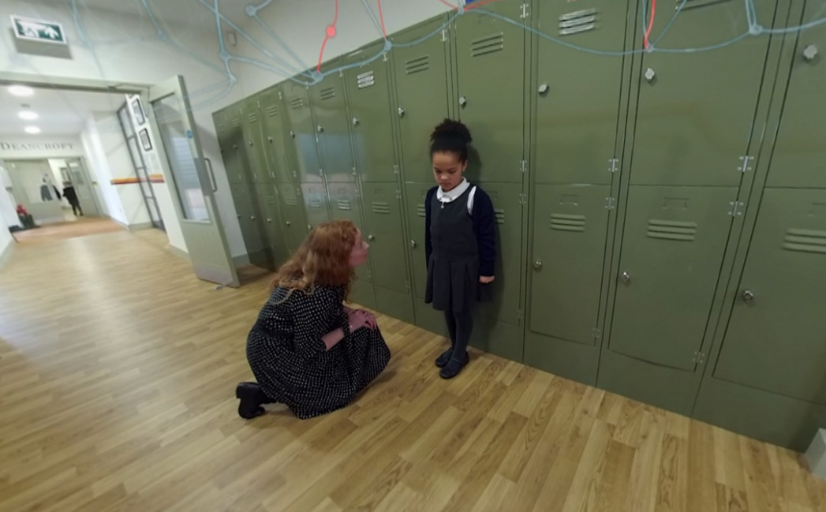

|  |
| --- |
| **Prompts for facilitating discussion with parents/carers** |
| * How did you find watching that film? * How has the PACE approach worked for Rayleigh? What did we notice about her responses? * How did her brain respond to the interaction? * What did Rayleigh learn from the interaction? What messages were communicated to her? * Would you be able to implement some of these techniques? |

|  |
| --- |
| **Prompts for facilitating discussion with professionals** |
| * What did you notice about the teacher’s therapeutic approach? How did that impact Rayleigh? * How was Rayleigh supported by the interaction? * How would Rayleigh be feeling following that interaction? * What measures can be introduced to support Rayleigh at school? * How would we record the incident? |

1. **RAYLEIGH AT HOME – STYLES A & B**

|  |
| --- |
| **Prompts for facilitating discussion with parents/carers** |
| * What did we notice happening in this interaction? * How did Rayleigh feel? What things do we need to consider for Rayleigh? * What was the carer feeling during these interactions? * How does this interaction mirror Rayleigh’s early life experiences? * Does Rayleigh feel important, lovable and safe? * How can Rayleigh be positively supported with her hygiene and hair care? * What does the carer need to prioritise at this stage? |

|  |
| --- |
| **Prompts for facilitating discussion with professionals** |
| * What did we observe during the interactions? * What styles of parenting were observed? How did each style impact on Rayleigh? * If all behaviour is communication, what was the carer communicating to Rayleigh? * What were the negatives and positives of the interaction? * Given the knowledge about Rayleigh’s early life experiences, what is likely to trigger Rayleigh during this interaction with her carer? |

1. **RAYLEIGH AT HOME – THERAPEUTIC APPROACH**

|  |
| --- |
| **Prompts for facilitating discussion with parents/carers** |
| * What worked well for Rayleigh in this response? * What was happening to her brain during this interaction? * How did her body language, tone, etc, make a difference for Rayleigh? * Was it helpful to see the PACE approach in action? What did we learn? * What did the carer consider prior to approaching the conversation? What was important in that moment? * Would you do anything different? |

|  |
| --- |
| **Prompts for facilitating discussion with professionals** |
| * What did we notice about this style of interaction? * How did Rayleigh respond? * How could we support Rayleigh’s home life? * What would you like to see included in Rayleigh’s assessments/EHC plan? * How would you interact with Rayleigh? * What are the key messages being given to Rayleigh? What is the likely impact of these messages in her life? |