THE DIGITAL WORLD
Objectives
- To introduce participant(s) to VR.
- To think about how consuming a range of media can contribute towards addiction and distraction from reality for a child/young person.
- To educate parents/professionals to support their young people in shifting their algorithms from negative to positive.

Target audience
- Young people
- Parents
- Carers
- Professionals

Guidance
- This is a guide so you may not want to use/ask every question. Be guided by your group.
- Take action points away from this. What can you do with the information?
- Take note of highlighted areas, as you can break these sessions down to run over several weeks/sessions.
- Think about potential outcomes and be prepared to offer additional support, for example thinking about additional VR experiences for use in another session.

Preparation
- Always prepare before delivery – i.e. what’s your objective? Are participants aware of what to expect? Do they know what VR is? Are they comfortable with you using VR with them?
- Introduce VR. Talk about what “fully immersive” means, for example it puts you into the perspective of a person/child. 360-degree viewing allows you to see things from a different perspective.
- Have you made participants aware of related health warnings, emotional (some videos contain distressing content and/or may cause feelings of anger/upset/fear) and physical (does the participant have any health issues that may be affected by using VR?).
- Explain other pre-viewing tips (e.g. stay seated/freedom to remove headset at any point/ look around to get the full experience).
- Explain the headset and controller.
- Ensure access to evaluation and consent forms.
- Follow up and continuation of learning from sessions is key to delivering change.

Closing the session and follow-up
- Complete evaluations.
- Check in with the participant(s) about how they are feeling following the VR experience(s) and the conversations you have had.
- Let them know who they can call for support, e.g. if anything comes up for them following the visit.
- Let them know you will follow up with them within the following working week to check in following the visit.

- INTRODUCTION TO THE DIGITAL WORLD
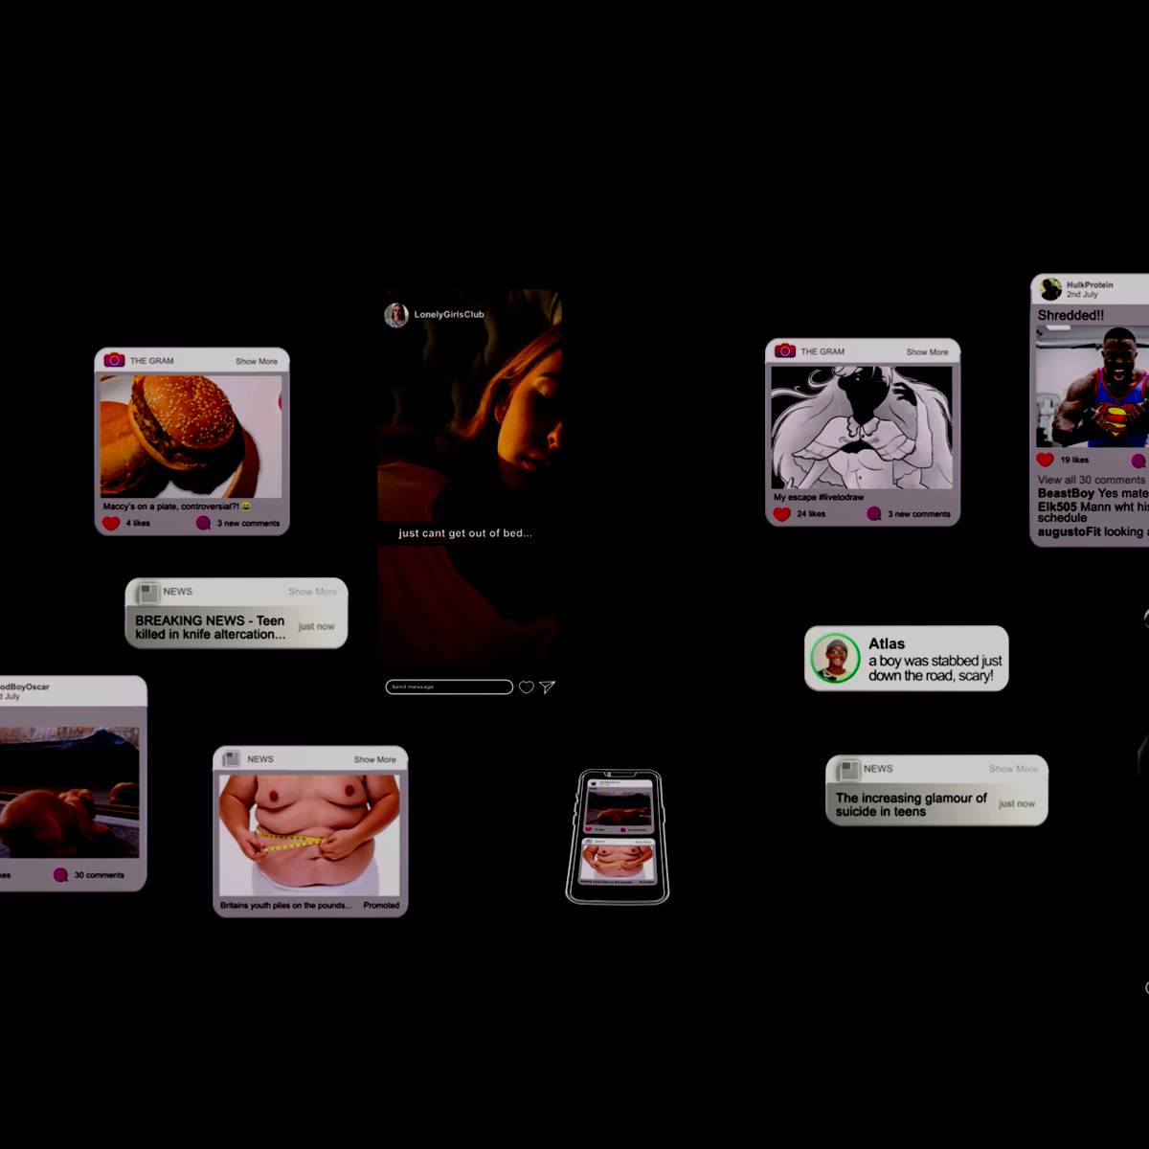
Prompts for facilitating discussion with young people
- How do you feel about social media? Did anything stand out for you?
- Have you received any of these types of messages before? How did you feel when you did?
- Does your adult understand about your use of social media?
- If you were concerned about any of the messages, is there someone you could talk to about it? If no, is there a reason for this?
- What is meant by digital footprint?
- Do you know what “doom scrolling” is?
- How long can you go without your phone/laptop/iPad (or other device)?
- Can you describe your social media use in three words?

Prompts for facilitating discussion with parents/carers
- Describe how you felt experiencing a day in the life?
- How comfortable do you feel about talking to your child/young person about social media? Positives and negatives.
- What were your thoughts about the amount of different social media posts, identifying both positives and negatives of social media?
- Were you aware of the different ways your child/young person could be contacted by strangers? How might you support and guide your child/young person?
- What support might you need to talk to your young person?

Prompts for facilitating discussion with professionals
- How did you experience this?
- How do you think young people experience this?
- What is your usual response to a young person who is immersed in their “virtual world”?
- How would you engage with a young person to understand their experiences?
- Image sharing is happening. How can we help children to navigate this world and feel empowered? What strategies can you help devise to manage this?

- DIGITAL WORLD: GAMING
Generalised functions of gaming offer escapism/avoidance of feelings, achievement/rewards, and connection/communication/acceptance.
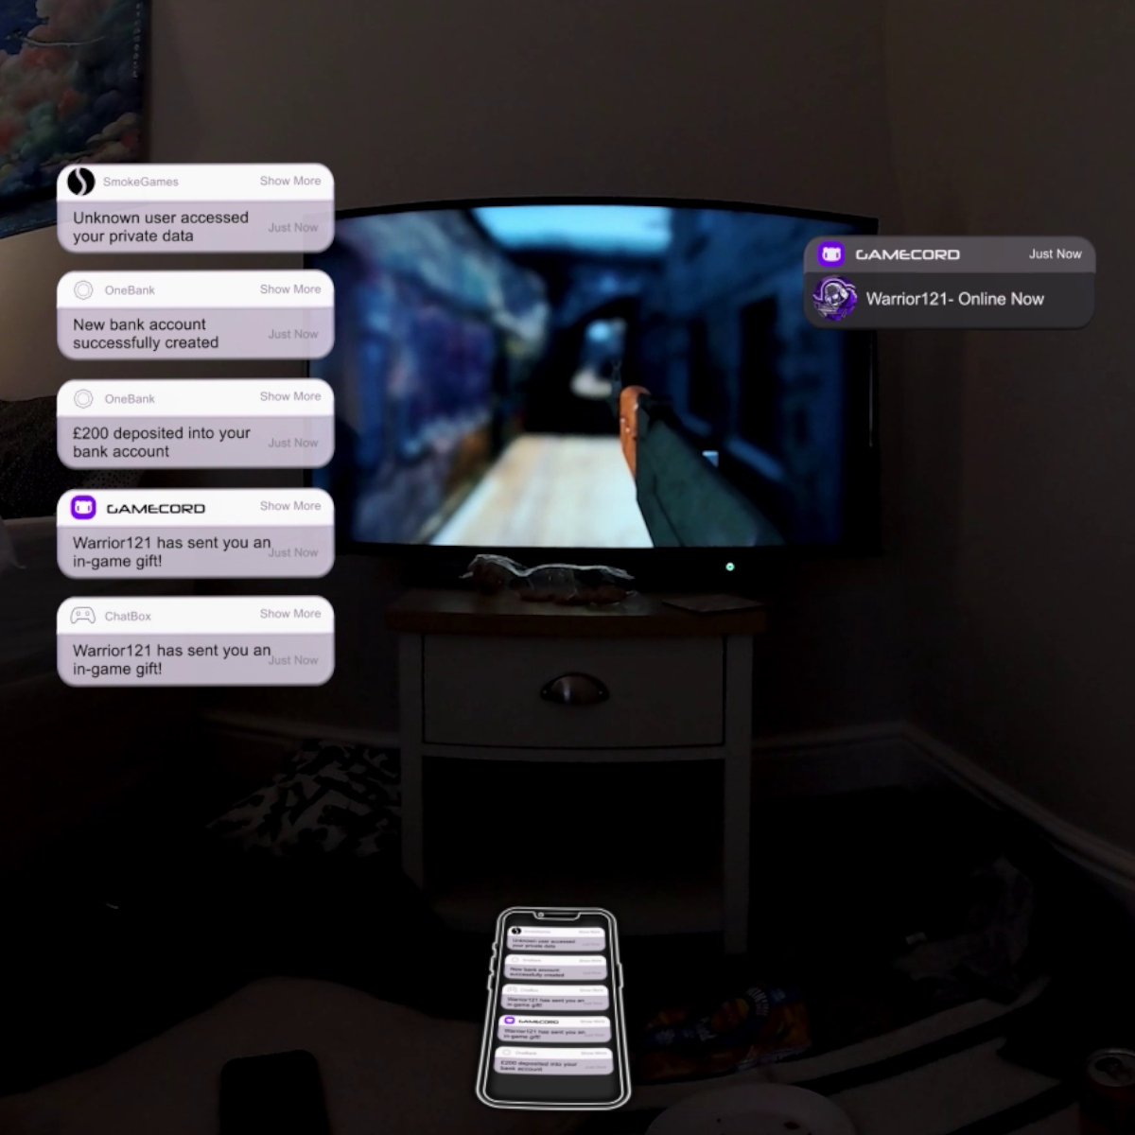
Prompts for facilitating discussion with young people
- Do you feel an impulse to play games?
- How do you know when emotions take over? What do you notice?
- When is it ever OK to share your personal information with someone?
- Would you consider Warrior121 a stranger or mate?
- How long do you need to know someone for them not to be a stranger? What does “stranger” mean to you?

Prompts for facilitating discussion with parents/carers
- You can watch this film alongside the adolescent brain content, as part of the limbic system is activated when gaming.
- Do you know how online gaming works? How do children connect with others?
- Do you have parental controls on consoles?
- How would you describe communication between you and your child/young person regarding gaming? For instance, is the parent/carer curious about their child/young person’s games to develop a better understanding.
- When thinking about setting boundaries, have you considered that games offer social interaction and asking your child to “come off” can be frustrating?
- Can other activities be introduced for the child, which meets the functions of gaming?

Prompts for facilitating discussion with professionals
- Consider the positives for children who are neuro-diverse. For example, the repetition of content and game predictability can be calming. Engaging with immersive content can reduce worry time.
- How might you use gaming as a form of building connections with your young person? Is it appropriate?
- From the gaming film, what’s your understanding of this?

- DIGITAL WORLD: DECEPTION OR OPPORTUNITY
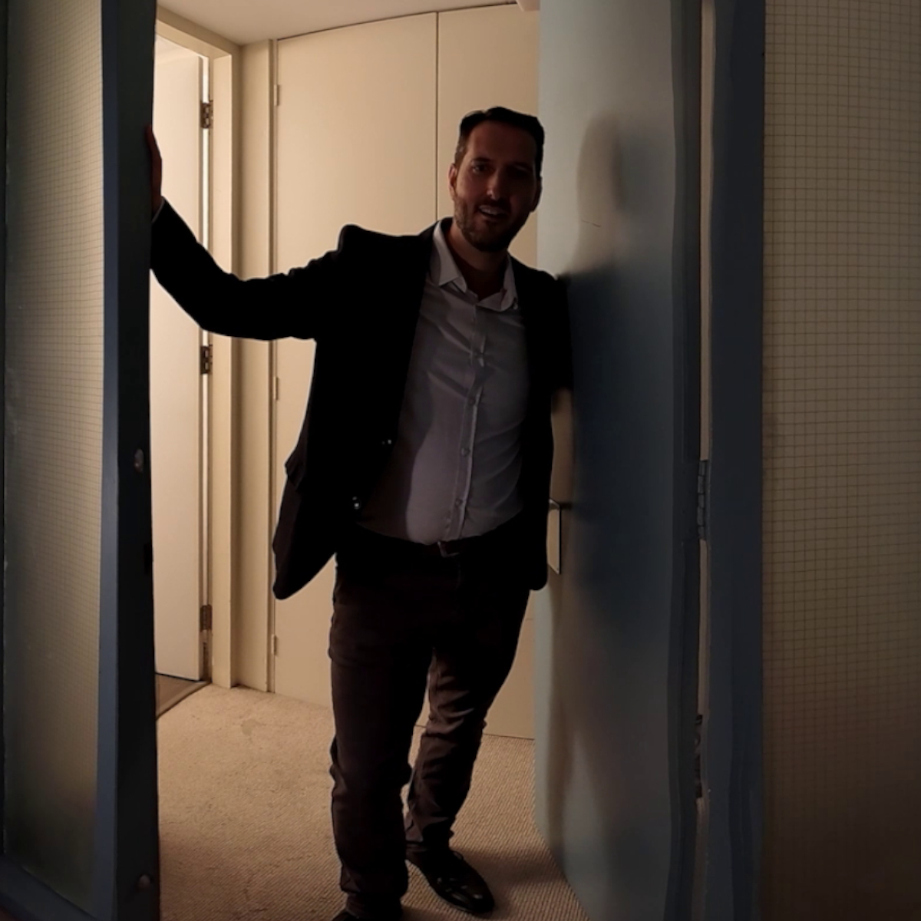
Prompts for facilitating discussion with young people
- Are there any red flags in the interaction?
- What do you notice about the language that is used?
- The friends both have different views about the meeting. What would your view be? How would you make an informed decision?
- Who could you talk to if you were concerned about being groomed?

Prompts for facilitating discussion with parents/carers
- What is your initial response? What do think will happen next?
- How would you support your child if they were being approached online?
- Do you know what help is available?
- Tell me how you know what your child is accessing online. Can your child talk to you about their interests and show you what they like to watch/access?

Prompts for facilitating discussion with professionals
- Think about the reachable moments within this film – Window of Opportunity - to understand what is happening in the child’s world and to provide support/intervention.
- How would you engage this child? What would this child need to help them think about the different outcomes? Hold in mind the adolescent brain and stages of development (i.e. susceptibility to risk-taking behaviour).
- Do you know the warning signs? How can you share this with the child?

- JUST SCROLLING

Health warning! Please remind viewers of the emotive nature of this film and that they can come out of headsets at any time.
Prompts for facilitating discussion with young people
- What do you notice happening in the VR experience?
- How did this experience make you feel?
- Do you know what “doom scrolling” is?
- Do you find your devices and the amount of information overwhelming?
- How would you feel if you switched your phone off for a few hours?

Prompts for facilitating discussion with parents/carers
- Do you know what is meant by the term “doom scrolling”?
- What are some of the issues emerging during the film?
- How would you describe the parental responses during the VR experience?
- How easy do you think it is for children to switch off from digital platforms?
- How do you manage your own digital use?
- Where can you go for help, for yourself as a parent?

Prompts for facilitating discussion with professionals
- How did that experience make you feel?
- What are the issues emerging?
- How would you support a child/young person experiencing the issues identified?
- What practical advice can be given (to parents, carers and children)?
- What does the heartbeat suggest?

Resources/further reading
For children and young people

- https://saferinternet.org.uk/guide-and-resource/young-people/resources-for-11-19s
- https://www.youngminds.org.uk/young-person/coping-with-life/social-media-and-mental-health/
- https://mentallyhealthyschools.org.uk/resources/reset-and-rewind-rap-therapy-videos/

For professionals

- Children's Media Lives 2022 summary report (ofcom.org.uk)
- Digital Wellbeing Resources - Who Cares? Scotland (whocaresscotland.org)
- Social media addiction - how it changes your brain | Luke Burgis | Big Think
- After A Few Minutes Of Social Media, This Happens - Neuroscientist Andrew Huberman
- Center for Digital Thriving - Teaching Digital Well-being.pdf - Google Drive
- From <https://www.ccinform.co.uk/knowledge (Web view)
- Sharing nudes and semi-nudes: how to respond to an incident (overview) (publishing.service.gov.uk)
- https://www.youtube.com/watch?v=hZIYSCE-ZjY
- Ofcom Consultation: Protecting people from illegal harms online. Ofcom, the regulator of the new Online Safety Act, will are working to establish the new regulations over the next 18 months.
- It focuses on illegal content and their proposals on how internet services that enable the sharing of user-generated content ('user-to-user services') such as social media, photo and video-sharing services, chat and instant messaging platforms, online and mobile gaming, as well as search services and pornography sites, should approach their new duties relating to illegal content.
- There is a particular focus in this consultation on ‘priority offences’ set out in the legislation, such as child abuse, grooming and encouraging suicide; but it will include any illegal content as set out in the Act https://lnkd.in/eaE53Fgn.
- The Online Safety Act received Royal Assent on the 26th October 2023 and made Ofcom the online safety regulator with a responsibility to help make online services safer for the people who use them.

For parents/carers

- https://esafetytraining.org/ On the parents’ resource page - they have information about different features on Instagram and TikTok
- https://www.nspcc.org.uk/keeping-children-safe/online-safety/social-media/
- https://www.thinkuknow.co.uk/parents/ask-the-awkward/asktheawkward-subtitled/ parents’ resource
- https://www.youtube.com/watch?v=89jOufetX1c – short film showing the dangers of grooming online
- https://www.internetmatters.org/resources/social-media-advice-hub/social-media-benefits/
- https://www.internetmatters.org/resources/
- https://www.childrenssociety.org.uk/what-we-do/blogs/how-tiktok-affects-childrens-mental-health

