**AISHA - CHILD SEXUAL EXPLOITATION**

|  |
| --- |
| **Objectives** |
| * Enable professionals to experience the world of a child exposed to Extra Familial Harm (EFH). * To promote the protective benefits of education for children at risk of EFH and reduce the chance of permanent or temporary exclusion. * Provide parents with the opportunity to experience the world of a child exposed to EFH. * To help parents understand the dangers their child is exposed to/at risk of, in relation to EFH. * To support parents to keep their children safe. * To open up a conversation with a young person about their risk of EFH. * To help young people identify their vulnerability. * To discuss alternative, less risky behaviours with young people. |

|  |
| --- |
| **Audience** |
| * Young People * Parents * Carers * Professionals |

|  |
| --- |
| **Guidance** |
| * This is a guide so you may not want to use/ask every question. Be guided by your group. * Refer to Aisha’s case study to support parents in thinking about the impact of past experiences on a child’s development, particularly considering self-worth and the stability of relationships. * You may want to adapt Aisha’s life journey (e.g. shorten it) for young people to read. * Take note of highlighted areas, as you can break these sessions down to run over several weeks/sessions. * Take action points away from this. What can you do with the information? * Think about potential outcomes and be prepared to offer additional support, for example thinking about additional VR experiences for use in another session. |

|  |
| --- |
| **Preparation** |
| * Always prepare before delivery – i.e. what’s your objective? Are participants aware of what to expect? Do they know what VR is? Are they comfortable with you using VR with them? * Introduce VR. Talk about what “fully immersive” means, for example it puts you into the perspective of a person/child. 360-degree viewing allows you to see things from a different perspective. * Have you made participants aware of related health warnings, emotional (some videos contain distressing content and/or may cause feelings of anger/upset/fear) and physical (does the participant have any health issues that may be affected by using VR?). * Explain other pre-viewing tips (e.g. stay seated/freedom to remove headset at any point/ look around to get the full experience). * Explain the headset and controller. * Ensure access to evaluation and consent forms. * Follow up and continuation of learning from sessions is key to delivering change. |

|  |
| --- |
| **Closing the session/follow up** |
| * Complete evaluations. * Check in with the participant(s) about how they are feeling following the VR experience(s) and the conversations you have had. * Let them know who they can call for support, e.g. if anything comes up for them following the visit. * Let them know you will follow up with them within the following working week to check in following the visit. |

1. **AISHA INTRODUCTION**

In this film, we see various things that may make Aisha scared, vulnerable and isolated. Please allow some time for silent reflection to allow for your participants to process the films.

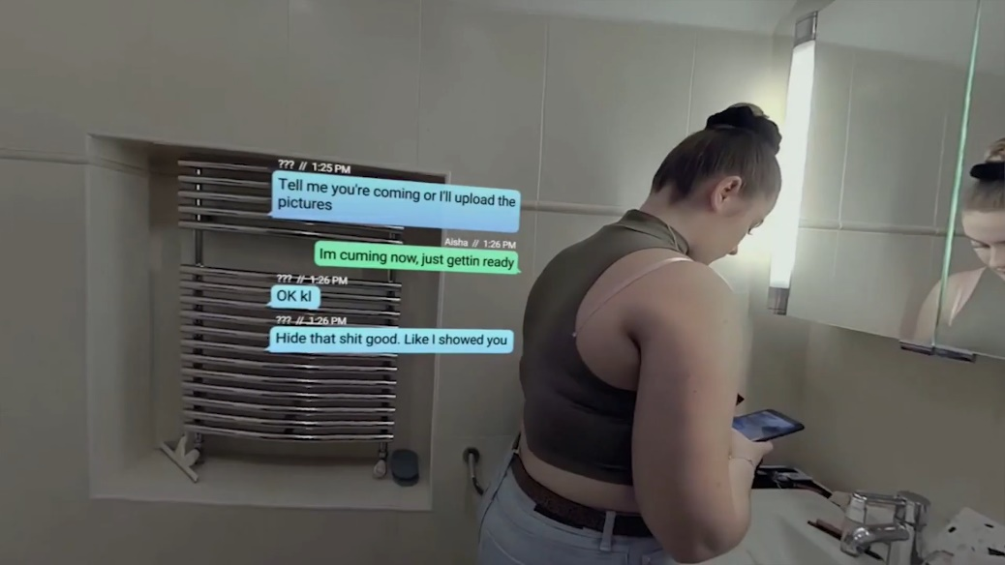

|  |
| --- |
| **Prompts for facilitating discussion with young people** |
| * How might Aisha be feeling? * Is it OK to receive a text like this from someone you are in a relationship with? * Who can Aisha talk to? Would she feel comfortable talking to a parent/carer/worker? * What choice do you think Aisha has? * Do you think she knows what her choices are? |

|  |
| --- |
| **Prompts for facilitating discussion with parents/carers** |
| Remember! This part is for your participants to feel supported and empowered in their learning. We are not wanting parents/carers to feel judged or shamed.   * What would your response be if you saw messages like this on your child’s phone? * What do you think they mean? * How might Aisha be feeling? * What do you think about the carer’s behaviour? Do you think Aisha feels comfortable to talk to her carer? * What choice do you think Aisha has? * Do you think she knows what her choices are? |

1. **AISHA A**

|  |
| --- |
| **Prompts for facilitating discussion with young people** |
| You may wish to start a discussion with young people about how early negative experiences, such as domestic abuse, may influence peer relationships.   * What do you notice happening for Aisha? * What do you think a young person would need from their carer at this point? * How do you think Aisha is feeling? * If Aisha could not go to her parent/carer, who else could she reach out to for support? |

|  |
| --- |
| **Prompts for facilitating discussion with parents/carers/professionals (adapt questions appropriately for your group). You may wish to refer to Aisha’s life journey in this section** |
| As a carer, you need to be curious about changes in behaviour. Discuss how they approach a young person when they are curious about changes in behaviour.   * What was going on for the carer? * What do you think would have helped Aisha in this moment? What does she need from her carer? * How do you think Aisha is feeling? * How do you think Aisha's past trauma links to her current situation? |

1. **AISHA B**

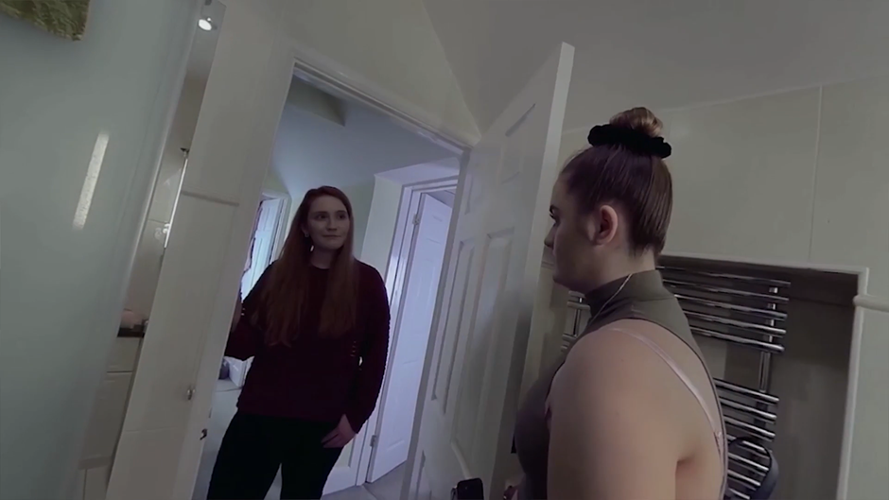

|  |
| --- |
| **Prompts for facilitating discussion with young people** |
| * Was the carers response helpful? * How do you think Aisha is feeling? * What advice would you give parents/carers regarding talking to their child about relationships? |

|  |
| --- |
| **Prompts for facilitating discussion with parents/carers/professionals (adapt questions appropriately for your group)** |
| * What did you observe happening? * What worked well in this film? * How did the carer work to form a connection with Aisha? * What changes did you notice in Aisha's body language? * What opportunities does this create for the young person and the carer’s relationship with them? |

1. **AISHA - CHILD SEXUAL EXPLOITATION**

Health warning! The film you are about to watch contains scenes viewers may find difficult.

**Different discussion points:** This session plan can cover a number of topics with young people and their support network(s). We have given you some options to consider. Always think about what your objective is for your participants.

|  |
| --- |
| **First session: prompts for facilitating discussion with young people** |
| Discuss consent in relation to sex. What is consent? Can consent be withdrawn at any point during a sexual encounter?   * How do you think Aisha is feeling? * What is happening for the girl in the bed? * What are the men in the bedroom thinking? What advice would you give to them? |

|  |
| --- |
| **Resources/further reading** |
| * <https://www.childline.org.uk/info-advice/friends-relationships-sex/sex-relationships/sex-consent/> * <https://www.youtube.com/watch?v=pZwvrxVavnQ> * <https://www.youtube.com/watch?v=1oyE-qE4340> * <https://www.uobcsepolicinghub.org.uk/assets/documents/RBF-2-Pearce-Short-video-briefing-paper.pdf> |

|  |
| --- |
| **Second session: prompts for facilitating discussion with young people** |
| The film above covers topics of rape and human trafficking. It might be that you are wanting to cover a session that educates young people around these topics, so that they can make informed decisions.   * In the film, Aisha is under the influence of alcohol. Does she have capacity to consent?   + Prompt. No, she does not, because she is intoxicated, therefore she’s unable to give consent. In this instance it is always rape and being in a relationship does not give automatic consent. * Do you know what rape is? * Aisha’s boyfriend has brought Aisha to the party to exploit her. Do you know how Aisha has been exploited? * Do you know about human trafficking? * Do you think Aisha has been trafficked? * How would you describe a healthy relationship? |

|  |
| --- |
| **Resources/further reading** |
| * <https://www.childline.org.uk/info-advice/friends-relationships-sex/sex-relationships/healthy-unhealthy-relationships/> * <https://www.nspcc.org.uk/what-is-child-abuse/types-of-abuse/child-trafficking/#what> * <https://www.childline.org.uk/info-advice/bullying-abuse-safety/abuse-safety/rape-sexual-assault/> |

|  |
| --- |
| **Prompts for facilitating discussion with parent/carers/professionals (adapt questions depending on group)** |
| Prompt: Do the group you are talking to understand what a healthy relationship is? Consider resources available to you and to direct them to. It might be that participants in your group have had difficult relationships in the past and/or continue to be in one.     * How do you think Aisha is feeling? * Do you feel confident or comfortable talking to your child about sex and consent? * How would you describe a healthy relationship? How can we model it to young people? |

|  |
| --- |
| **Resources/further reading** |
| * <https://www.childline.org.uk/info-advice/friends-relationships-sex/sex-relationships/healthy-unhealthy-relationships/> * [Did you see that coming? - YouTube](https://www.youtube.com/watch?v=Rfw-KqlYxQI) |

1. **AISHA DISCLOSURE**

|  |
| --- |
| **Prompts for facilitating discussion with young people** |
| * What do you think helped Aisha to talk to her carer about being sexually exploited? * What do you think young people need from their key people (e.g. parents/carers/teachers/coaches) to help them have difficult conversations such as talking about someone sexually exploiting them? |

|  |
| --- |
| **For parents/carers/professionals** **(adapt questions appropriately for group)** |
| * How did the carer create space for Aisha to talk? * How did she create safety for Aisha? * What impact did it have on Aisha and the way she was feeling? * How did the carer manage the disclosure? * What would get in the way of you being able to respond to Aisha in this way? * What would you do with the information Aisha shared? |