

**Session Plan: Angie**

**Purpose of the session**

**Objectives**

* Increase knowledge on the exploitation of vulnerable adults.
* Provide real life scenarios, that aid the participants in identifying risks and safety strategies.
* Increase confidence in supporting vulnerable adults and young people at risk of or being exploited.
* Reflect on practice and opportunities to engage with vulnerable adults and young people when faced with barriers, such as control (i.e., from perpetrators).

**Target audience for the session**

* Practitioners
* Police
* Housing

**Advice:**

* This is a guide; you may not want to use/ask every question. Be guided by the group or individual.
* Take action points away from this - what can you do with the information?
* Think about potential outcomes and be prepared to support even if the outcome is not expected - for example, linking to other films for another session maybe 1:1 with participant.

**Preparation:**

* Always consider preparation of session(s) prior to delivery - what’s your objective? Are participants aware of what to expect? Do they know what VR is? Are they comfortable with you using VR with them?
* Introduce VR. Talk about what ‘fully immersive’ means, for example it gets you in the situation of a person/child. 360-degree experiences allow you to see things from a different perspective.
* Have you made participants aware of health warnings, emotional (some videos may contain distressing content and/or cause feelings of anger/upset/fear) and physical (e.g., does the participant have any health issues that may be affected by using VR)?
* Explain other pre-viewing tips (e.g., stay seated/freedom to remove headset at any point/look all around you to get the full experience).
* Explain the headset and controller.
* Ensure access to evaluation and consent forms.
* Follow up and continuation of learning from sessions is vital in delivering change.

**Angie and Joe in the trap house (film is referred to as Joe - Gangs/Drugs in Trap house)**

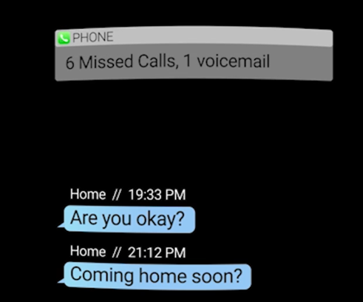

1. What is a ‘trap house’?
2. What is ‘cuckooing’?
3. What are the signs that cuckooing may be going on at a property?
4. Name five things that you’ve noticed.
5. What do you think Zac means by the pharmacy is here for you now?
6. Is Joe at risk?
7. Is Angie at risk?
8. What have you observed that makes Angie vulnerable?
9. How might you support them?
10. Is this exploitation? If so, who is being exploited in this video?
11. What could Joe do in this situation to keep himself safe?
12. What can Angie do to keep herself safe?

**Angie’s profile**

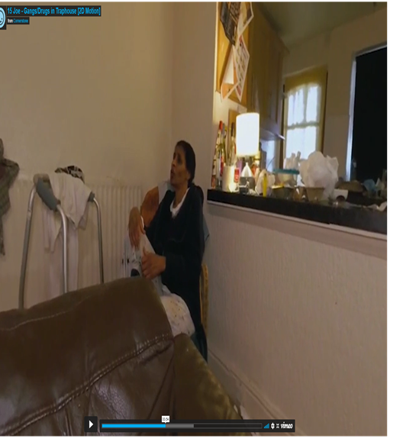

**Action:** Now read Angie’s life journey document.

1. Does this change your views, now you have more detail?
2. Do you think Angie has capacity to make informed decisions?
3. How might you support Angie?
4. Who would you contact?

**Discussion point around professional duties:**

1. If you’re the social worker/carer/housing officer, for Angie, what are your duties towards Joe and Angie?
2. What are the powers and tools which can be used to remove the people who are exploiting and keep the tenant safe?
3. A multi-agency response is key to working to address concerns around cuckooing and exploitation, which agencies would need to be involved?