

**Session Plan: Young Rayleigh**

**Purpose of the session**

**Objectives:**

* To increase knowledge of trauma informed response in carers/ parents and professionals.
* To provide real life scenarios to aid the parents/ carers/ professionals to increase self-awareness.
* To raise awareness and importance of self-care, and aid participant to increase this in their lifestyle.
* To increase confidence in participants supporting vulnerable children and young people.

**Target audience for the session:**

* Parents
* Carers
* Family members
* Professionals

**Advice:**

This is a guide; you may not want to use/ ask every question- be guided by your group.

* Refer to Rayleigh case study to support parents think about impact of past experiences on young person’s development, thinking about young person’s self-worth and stability of relationships.
* Take note of highlighted areas, as you can break these sessions down to run over several weeks/sessions.
* Take action points away from this - what can you do with the information.
* Think about potential outcomes and be prepared to support - for example, linking to other films for another session maybe 1:1 with participant.

**Preparation:**

Always consider preparation of session(s) prior to delivery - what’s your objective? Are participants aware of what to expect? Do they know what VR is? Are they comfortable with you using VR with them?

* Introduce VR. Talk about what ‘fully immersive’ means, for example it gets you in the situation of a person/child. 360-degree experiences allow you to see things from a different perspective.
* Have you made participants aware of health warnings, emotional (some videos may have some distressing content and/or cause feelings of anger/upset/fear) and physical (e.g., does the participant have any health issues that may be affected by using VR)?
* Explain other pre-viewing tips (e.g., stay seated/freedom to remove headset at any point/ look all around you to get the full experience).
* Explain the headset and controller.
* Ensure access to evaluation and consent forms.
* Follow up and continuation of learning from sessions is vital to delivering change.

**The Unborn Child’s View**

In this film of unborn Rayleigh we see the impact of domestic abuse and substance misuse.

*Health Warning- please do remind viewers of the emotive nature of this film and that they can come out of headsets at any time.*

**For session with parent/carers:**

* How did you find watching that?
* How are you feeling now?
* What were some factors you noticed impacting on the unborn child?
* How much did you understand about a baby’s developing brain and their experiences prior to being born?

**For session with professionals:**

* How did you find watching that film?
* What were some factors you noticed impacting on the unborn child?
* How might watching this film impact on your assessment skills?
* What’s you’re understanding about sensory memories, now think about the children and young people you’re working with and what we know about their pre-birth experiences, does this film help you understand their world better?

**Carnaby Street**

In this film we experience the impact of abandonment, neglect, abuse and shaming through the eyes of 18-month-old Rayleigh.

*Health Warning- please do remind viewers of the emotive nature of this film and that they can come out of headsets at any time.*

**For session with parent/carers:**

* How was the child in Carnaby St feeling?
* Do you know of anyone who has had a similar experience?
* What impact would these early life experiences have on this child? What behaviours and emotional responses do you think they might demonstrate?
* What might that look like for the child at age 4, 8, 12, 16? What challenges might this present?
* How would you feel caring for a child who has experienced this?
* What was the experience of the male caregiver?
* What was the experience of the female caregiver?
* How would you support this child’s contact and relationship with their parents?
* How might this impact on their relationships?
* If this child didn’t have food regularly, what impact might this have?
* If this child was unable to have their emotional and safety needs met, what impact might this have?

**For session with professionals:**

* What are the key issues you observed?
* What is the impact on the child’s brain development?
* What impact would these early life experiences have on this child? What behaviours and emotional responses do you think they might demonstrate?
* What might that look like for the child at age 4, 8, 12, 16?
* Does the age of the child change your risk assessment?
* What support can you put in place for the child?

**School Triggers Introduction**

**For session with parent/carers:**

* What do we notice in this video?
* What is happening for Rayleigh?
* If you feel triggered, do you know what you can do to make yourself feel better, to self-regulate?
* Task- Complete the self-care wheel.
* Did this feel easy to complete? Are the activities you’ve written down something that you can do easily?
* Can you describe how you might respond if in this situation?
* How would you support Rayleigh to understand what is happening for her?

**For session with professionals:**

* What did you notice about Rayleigh’s brain?
* What triggers did you notice Rayleigh experience? How does this link to her early experiences?
* What do you notice about her interaction with the children?
* What impact would this have on her feelings of safety and ability to learn at school? What impact does this have for her life?

**Rayleigh at School Style A & B**

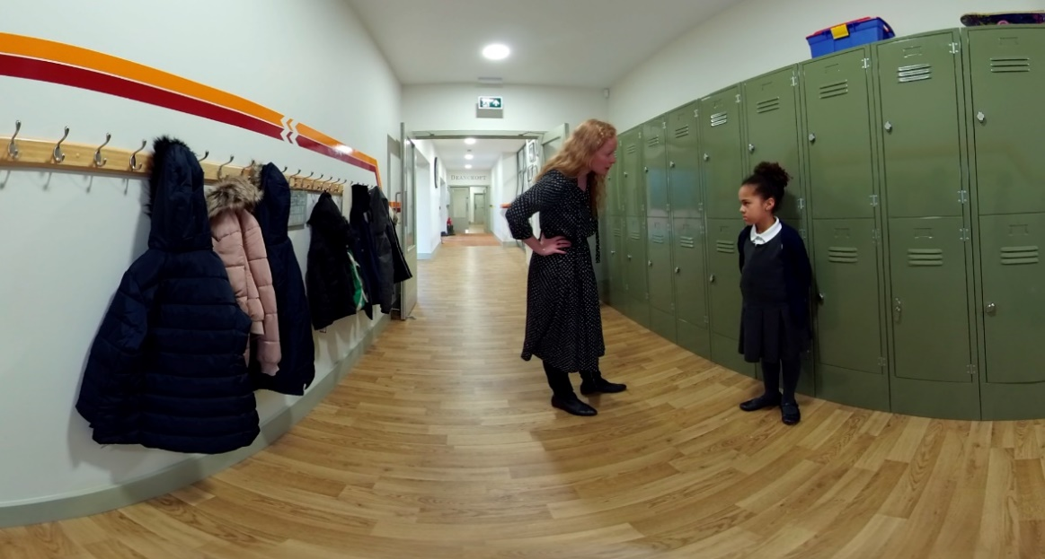

**For session with parents/carers:**

* What is important for Rayleigh in this interaction?
* What did you notice in this film? What stood out for you?
* How was Rayleigh’s brain responding to the teacher?
* What messages was she receiving within this interaction?

**For session with professionals:**

* What did you notice in this film? What stood out for you?
* Compare the two responses – what worked well and what did not work well?
* What did you notice about the teacher in film A? How did that impact Rayleigh? (yelling, instantly blamed Rayleigh, didn’t listen, unsafe)
* What did you notice about the teacher in film B? How did that impact Rayleigh?
* Does Rayleigh feel supported?
* Do you think the teacher would have managed it differently if they knew about her early experiences? If so, why does that make a difference?

**Rayleigh at School – Therapeutic Approach**

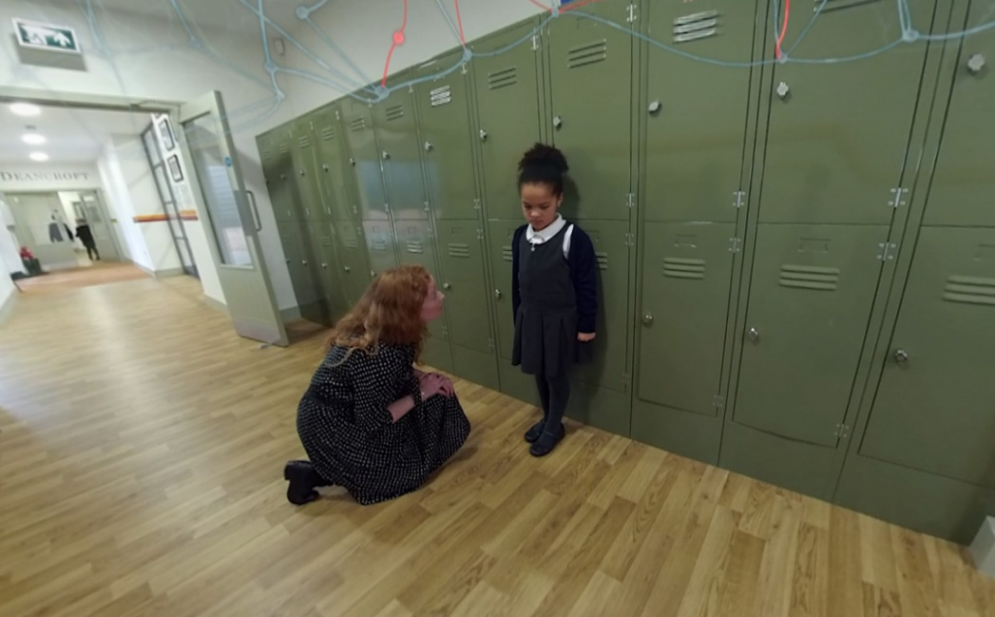

**For session with parent/ carers:**

* How did you find watching that film?
* How has the PACE approach worked for Rayleigh? What did we notice about her responses?
* How did her brain respond to the interaction?
* What did Rayleigh learn from the interaction? What messages were communicated to her?
* Would you be able to implement some of these techniques?

**For session with professionals:**

* What did you notice about the teacher in the Therapeutic approach? How did that impact Rayleigh?
* How was Rayleigh supported by the interaction?
* How would Rayleigh be feeling following that interaction?
* What measures can be introduced to support Rayleigh at school?
* How would we record the incident?

**Rayleigh at Home – Style A & B**

**For session with Parents/Carers**

* What did we notice happening in this interaction?
* How did Rayleigh feel? What things do we need to consider for Rayleigh?
* What was the carer feeling during these interactions?
* How does this interaction mirror Rayleigh’s early life experiences?
* Does Rayleigh feel important, lovable, safe?
* How can Rayleigh be positively supported with her hygiene and hair care?
* What does the carer need to prioritise at this stage?

**For session with professionals**

* What did we observe during the interactions?
* What styles of parenting were observed? How did each style impact on Rayleigh?
* All behaviour is communication – what was the carer communicating to Rayleigh?
* What were the negatives and positives of the interaction?
* Given the knowledge about Rayleigh’s early life experiences – what is likely to trigger Rayleigh during this interaction with her carer?

**Rayleigh at Home – Therapeutic Approach**

**For session with parents/carers:**

* What worked well for Rayleigh in this response?
* What was happening to her brain during this interaction?
* How did her body language, tone etc make a difference to Rayleigh?
* Was it helpful to see the PACE approach in action? What did we learn?
* What did the carer consider prior to approaching the conversation? What was important in that moment?
* Would you do anything different?

**For session with professionals:**

* What did we notice about this style of interaction?
* How did Rayleigh respond?
* How could we support Rayleigh’s home life?
* What would you like to see included in Rayleigh’s assessments/EHC plan?
* How would you interact with Rayleigh?
* What are the key messages being given to Rayleigh? What is the likely impact of these messages in her life?

**Closing the session and follow up:**

* Complete the evaluation form.
* Check in with the participants about how they are feeling following the VR experience and the conversations you have had.
* Let them know who they can call the for support if anything comes up for them following the visit.
* Let them know you will follow up with them within the following working week to check in following the visit.