**Session Plan: Aisha**

**Purpose of the session**

**Objectives**

* Enable professionals to experience the world of a child exposed to Extra Familial Harm (EFH).
* To promote the protective benefits of education for children at risk of EFH and reduce the chance of permanent or temporary exclusion.
* Provide parents with the opportunity to experience the world of a child exposed to EFH.
* To help parents understand the dangers their child is exposed to/at risk of, in relation to EFH.
* To support parents to keep their children safe.
* To open up a conversation with a young person about their risk of EFH.
* To help young people identify their vulnerability.
* To discuss alternative, less risky behaviours with young people.

**Target audience for the session**

* Young People
* Parents/carers
* Professionals (from Aisha A film)

**Advice:**

* This is a guide; you may not want to use/ask every question - be guided by your group or individual.
* Refer to Aisha’s life journey to support parents to think about the impact of past experiences on a young person’s development, thinking about self-worth and the stability of their relationships.
* You may want to adapt Aisha’s life journey - and shorten it - for young people to read.
* Take note of highlighted areas, as you can break these sessions down to run over several weeks/sessions.
* Take action points away from this - what can you do with the information?
* Think about potential outcomes and be prepared to support even if the outcome is not expected.

**Preparation:**

* Always consider preparation of session(s) prior to delivery - what’s your objective? Are participants aware of what to expect? Do they know what VR is? Are they comfortable with you using VR with them?
* Introduce VR. Talk about what ‘fully immersive’ means, for example it gets you in the situation of a person/child. 360 degree experiences allow you to see things from a different perspective.
* Have you made participants aware of health warnings, emotional (some videos may have some distressing content and/or cause feelings of anger/upset/fear) and physical (e.g. does the participant have any health issues that may be affected by using VR)?
* Explain other pre-viewing tips (e.g. stay seated/freedom to remove headset at any point/ look all around you to get the full experience).
* Explain the headset and controller.
* Ensure access to evaluation and consent forms.
* Follow up and continuation of learning from sessions is vital to delivering change.

**Aisha Introduction**

In this film, we see various things that may make Aisha scared, vulnerable and isolated.

*Please allow some time for silent reflection to allow for your participants to process the films.*

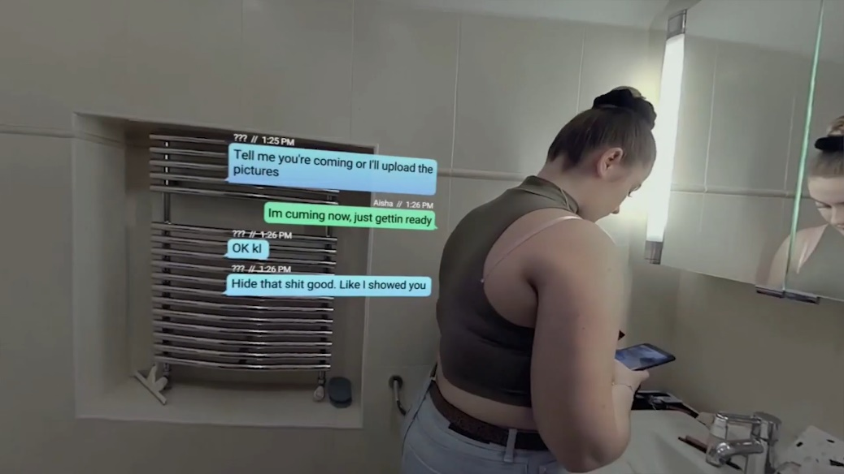

**For session with young people:**

* How might Aisha be feeling?
* Is it ok to receive a text like this from someone you are in a relationship with?
* Who can Aisha talk to?

(Prompt: would she feel comfortable talking to a parent/carer/worker?)

* What choice do you think Aisha has?
* Do you think she knows what her choices are?

**For session with parents/carers:**

**Prompt:** *This part is for your participants to feel supported and empowered in their learning. We are not wanting parents/carers to feel judged or shamed.*

* What would your response be if you saw messages like this on your child’s phone?
* What do we think they mean?
* How might Aisha be feeling?
* What do you think about the carer’s behaviour? Do you think Aisha feels comfortable to talk to her carer?
* What choice do you think Aisha has?
* Do you think she knows what her choices are?

**Aisha A**

**For session with young people:**

***Prompt****- you may wish to start a discussion with young people about how early negative experiences such as domestic abuse may influence peer relationships.*

* What do you notice happening for Aisha?
* What do you think a Young Person would need from their carer at this point?
* How do you think Aisha is feeling?
* If Aisha could not go to her parent/carer, who else could she reach out to for support?

**For session with parents/carers/ professionals (adapt questions appropriately for your group):** refer back to Aisha’s life journey in this section.

**Prompt**- As a carer, you need to be curious about changes in behaviour - discussion about how they approach a young person when they are curious about changes in behaviour.

* What was going on for the carer?
* What do you think would have helped Aisha in this moment? What does she need from her carer?
* How do you think Aisha is feeling?
* How do you think Aisha's past trauma links to her current situation?

**Aisha B**

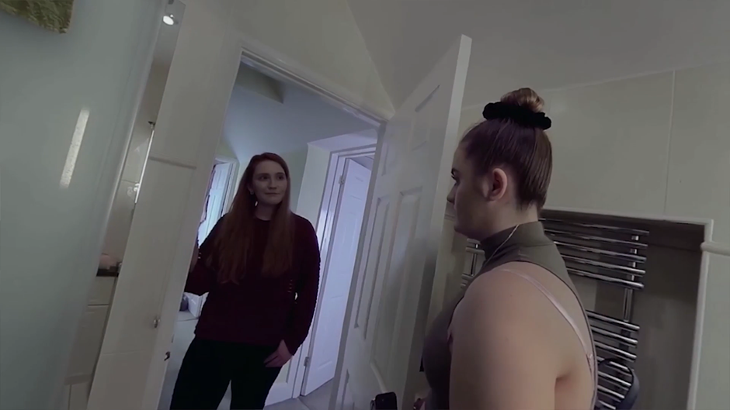

**For Session with young people:**

* Was the carers response helpful?
* How do you think Aisha is feeling?
* What advice would you give parents/ carers on talking to their child about relationships?

**For Session with parents/carers/ professionals (adapt questions appropriately for your group):**

* What did you observe happening?
* What worked well in this film?
* How did the carer work to form a connection with Aisha?
* What changes did you notice in Aisha's body language?
* What opportunities does this create for the young person and the carer’s relationship with them?

**Aisha - Child Sexual Exploitation:**

Health warning: The film you are about to watch contains scenes viewers may find difficult.

Different discussion points: This session plan can cover a number of topics with young people, and their support network. We have given you some options to consider. Always think about what your objective is for your participants.

**First session with young people:**

**Prompt** - discussion about consent to sex - what is consent? Can consent be withdrawn at any point during a sexual encounter?

* How do you think Aisha is feeling?
* What is happening for the girl in the bed?
* What are the men in the bedroom thinking? What advice would you give to them?

Resources -   
<https://www.childline.org.uk/info-advice/friends-relationships-sex/sex-relationships/sex-consent/>

<https://www.youtube.com/watch?v=pZwvrxVavnQ>

<https://www.youtube.com/watch?v=1oyE-qE4340>

<https://www.uobcsepolicinghub.org.uk/assets/documents/RBF-2-Pearce-Short-video-briefing-paper.pdf>

**Second session with young people:**

**Prompt-** The film above covers topics of rape and human trafficking, it might be that you are wanting to cover a session that educates young people around these topics so that they can make informed decisions

* In the film Aisha is under the influence of alcohol, does she have capacity to consent?

(Prompt: No, she does not, because she is intoxicated, therefore is unable to give consent, it is always rape, being in a relationship does not give automatic consent)

* Do you know what rape is?
* Aisha’s boyfriend has brought her to the party to exploit Aisha. Do you know how Aisha has been exploited?
* Do you know about human trafficking?
* Do you think Aisha has been trafficked?
* How would you describe a healthy relationship?

Resources-

<https://www.childline.org.uk/info-advice/friends-relationships-sex/sex-relationships/healthy-unhealthy-relationships/>

<https://www.nspcc.org.uk/what-is-child-abuse/types-of-abuse/child-trafficking/#what>

<https://www.childline.org.uk/info-advice/bullying-abuse-safety/abuse-safety/rape-sexual-assault/>

**For session with parent/carers/ professionals (adapt questions depending on group):**

**Prompt:** Do the group you are talking to understand what a healthy relationship is, consider resources available to you and to direct them to. It might be participants in your group have had difficult relationships in the past and continue to be in one.

* How do you think Aisha is feeling?
* Do you feel confident or comfortable talking to your child about sex and consent?
* How would you describe a healthy relationship? How can we model it to young people?

Resources-

<https://www.childline.org.uk/info-advice/friends-relationships-sex/sex-relationships/healthy-unhealthy-relationships/>

**Aisha Disclosure**

**For young people:**

* What do you think helped Aisha to talk to her carer about being sexually exploited?
* What do you think young people need from their key people (parents/carers/teachers/coaches) to help them have difficult conversations, such as talking about someone sexually exploiting them?

**For parents/carers/ professionals** **(adapt questions appropriately for group):**

* How did the carer create space for Aisha to talk?
* How did she create safety for Aisha?
* What impact did it have on Aisha and the way she was feeling?
* How did the carer manage the disclosure?
* What would get in the way of you being able to respond to Aisha in this way?
* What would you do with the information Aisha had shared?