

**Session Plan: Joe**

**Purpose of the session**

* To increase knowledge around exploitation and increase young people’s awareness of the signs and processes groomers might use.
* To provide real-life scenarios to aid the young person in identifying risks and safety strategies.

**Objectives**

* Increase the impact of the team’s interventions.
* Reduced risk of exploitation and offending associated with CCE.

**Target audience for the session**

* Children and young people, at risk of exploitation (ages 10-18).
* Exploited children and young people (ages 10-18).
* Parents/carers.

**Advice:**

* This is a guide; you may not want to use/ask every question. Be guided by your group.
* Take action points away from this - what can you do with the information.
* Take note of highlighted areas, as you can break these sessions down to run over several weeks/sessions.
* Think about potential outcomes and be prepared to support - for example, linking to other films for another session maybe 1:1 with the participant.

**Preparation:**

* Always consider preparation of session(s) prior to delivery - what’s your objective? Are participants aware of what to expect? Do they know what VR is? Are they comfortable with you using VR with them?
* Introduce VR. Talk about what ‘fully immersive’ means, for example it gets you in the situation of a person/child. 360 degree experiences allow you to see things from a different perspective.
* Have you made participants aware of health warnings, emotional (some videos may have some distressing content and/or cause feelings of anger/upset/fear) and physical (e.g. does the participant have any health issues that may be effected by using VR)?
* Explain other pre-viewing tips (e.g. stay seated/freedom to remove headset at any point/ look all around you to get the full experience).
* Explain the headset and controller.
* Ensure access to evaluation and consent forms.
* Follow up and continuation of learning from sessions is vital to delivering change.

|  |  |
| --- | --- |
| **Instructions** | **Discussion points** |
| 1. Watch this short film of Joe at school. | * Joe becoming frustrated and isolated * Mental health difficulties (Dad not involved - no one to talk to) * Possibly being bullied: would this be a pull factor if someone was to befriend him? * Would this cause Joe to start missing classes/not attending? Does this make him more vulnerable? |
| 1. Watch this short film of Joe meeting his friends. | * Pull factors: older male with status and respect * Opportunity to make money and get a new phone * Peer on peer: initially introduced by his school friend * Do they identify this as the start of the grooming process |
| 1. Watch the next film that shows Joe now in a car with the man he met/was introduced to outside the food shop. | * Use of fear/intimidation * Lack of choice for Joe - feels pressured * Safety strategies- what could Joe do/who could he speak to * Debt bondage if drugs get taken * Coaching Joe in how to behave/act around police (isolating him further) * Who is at risk here? The older male has none of the risks Joe may be facing |
| 1. Watch the video of Joe in a trap house.   **This film may contain emotional/triggering scenes- please speak to a trusted adult if you have concerns. | * Dangers of trap houses (weapons and used needles present, risk of being raided) * Being reported missing * Cuckooed addresses * Plugging of drugs * Threats to other ‘runner’ * Safety planning: exits and safety strategies * Did it feel like Joe had any choices? |



**Joe at School**

**Joe at school**

In this clip of Joe, we see various things that may make Joe frustrated, vulnerable or isolated.

**Task:** Look at the screenshots from the video and identify what is going on for Joe in these clips and how he might be feeling at each point.

*Some hints have been given to help you.*

|  |  |
| --- | --- |
|  | *What is going on for Joe here? (Hint: who are the texts from?)*      *How might this make Joe feel?* |
|  | *What is going on for Joe here? (Hint: Is Joe possibly being bullied?)*      *How might this make Joe feel?* |
|  | *What is going on for Joe here? (Hint: the teacher didn’t get his name right)*      *How might this make Joe feel? (Hint: would he feel comfortable speaking about his issues to a teacher who he thinks doesn’t care?)* |
|  | *What is going on for Joe here? (Hint: Is he distracted, might he be punished?)*  *How might this make Joe feel?* |



**Joe in the Car**

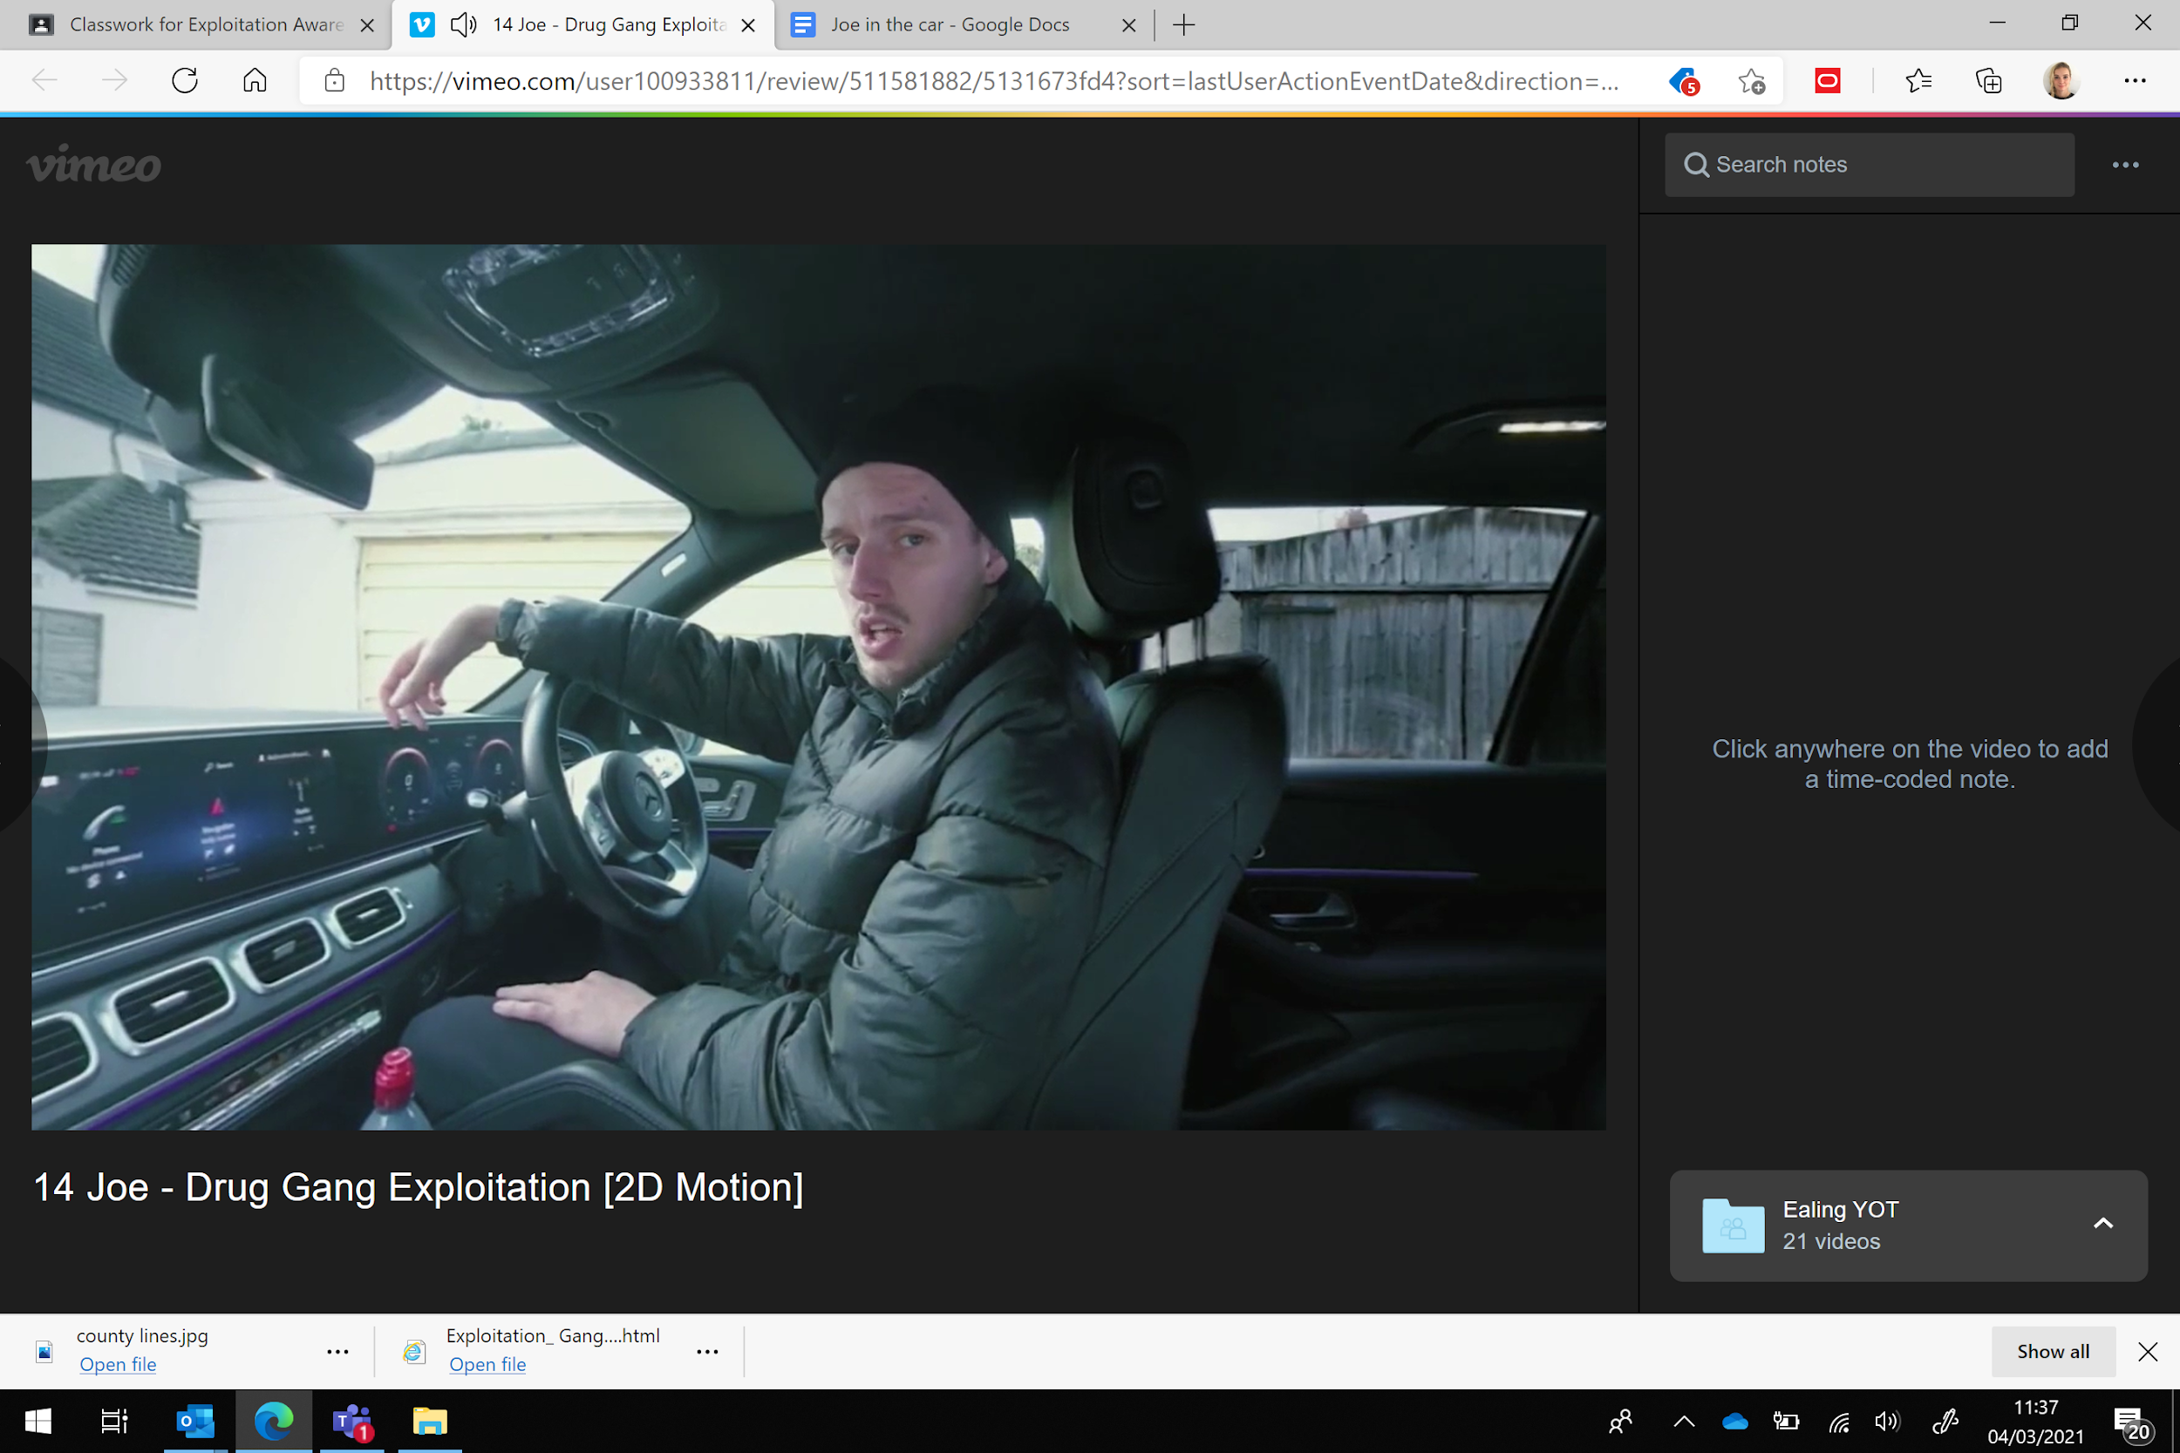**Joe in the car**

Q1) What happened in this video?

Q2) Is this exploitation? If so, why?

Q3) How might Joe be feeling?

Q4) What risks do you think Joe may face?

Q5) What do you think might happen if Joe gets caught by the police?

Q6) What might happen if Joe loses the drugs/gets these taken away?

Q7) What would your advice to Joe be in this situation?

Q8) Who could Joe speak to about this?



**Joe with Friends**

**Joe with Friends**

Context:

Joe has a difficult relationship with his dad and has been placed in foster care. Earlier in the morning, Joe was texting his Dad who finally reached out to him and he dropped his phone, breaking its screen. Joe then lashed out and shouted at his foster carer, after they were trying to find a spare phone in the house. He then left and met up with his friend who invited him to a fast-food shop. When Joe arrives, he greets his friend who is with an older male he does not know.

1. What might Joe’s emotional state be before arriving at the fast-food shop?
2. How might Joe be feeling, now, at the fast-food shop?
3. What did you notice in the video?
4. Is there anything that you think Joe should be worried about?
5. Who in the video do you think Joe should be cautious of and why?
6. What do you think the older male meant by “you do a couple jobs and he’ll hook you up”?
7. What risks are there?
8. What should Joe do in this situation/what would your advice be for Joe?



**Joe in the Traphouse**

**Joe in the trap house**

1. 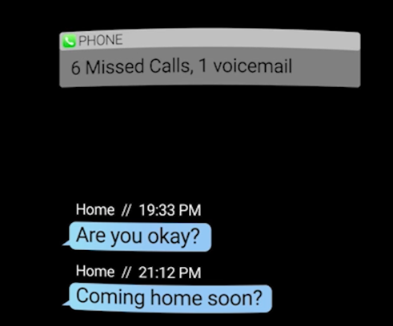What is a trap house?
2. Joe has missed several calls and texts from his foster carer. What might happen if she can’t get hold of Joe? (Hint: Joe may be seen as ‘missing’).
3. What might this tell you about Joe’s situation? (Hint: Is Joe being allowed to use his phone?)

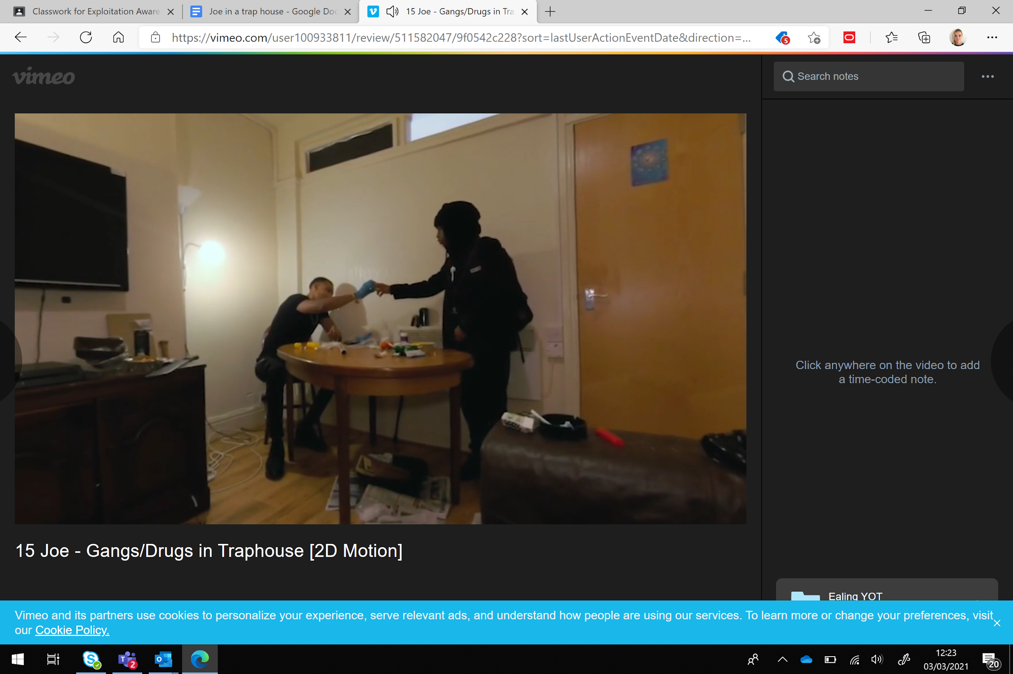

1. What did you notice in the video?
2. What risks can you identify? Use the image above to help you. (Hint: what items can you see?)
3. Whose address do you think this is/who lives at this address?
4. Where do you think the older male was indicating for Joe to hide the drugs?
5. Is this exploitation? If so, who is being exploited in this video?
6. What could Joe do in this situation to keep himself safe?
7. Does it feel like Joe has any choices in this situation?

**Closing the session and follow up**

* Complete the evaluation form.
* Check in with the participant about how they are feeling following the VR experience and the conversations you have had.
* Let them know who they can call the for support if anything comes up for them following the visit.
* Let them know you will follow up with them within the following working week to check in following the visit.